AIM
SUPPLIER INVOICE INBOUND
MD.120 deployment Instructions
Raya International Services

Author: Varun Sai Kumar Jonna
Creation Date: JUNE 05, 2024
Last Updated:
Version: 1.0

Title, Subject, Last Updated Date, Reference Number, and Version are marked by a Word Bookmark so that they can be easily reproduced in the header and footer of documents. When you change any of these values, be careful not to accidentally delete the bookmark. You can make bookmarks visible by selecting Tools->Options…View and checking the Bookmarks option in the Show region.

Approvals:
<Approver 1>
<Approver 2>
To add additional approval lines, press [Tab] from the last cell in the table above.
 Copy Number _____
You can delete any elements of this cover page that you do not need for your document. For example, Copy Number is only required if this is a controlled document and you need to track each copy that you distribute.

Document Control

Change Record
3
Date | Author | Version | Change Reference
 |  | Ver 1.0

Reviewers

Name | Position

Distribution

Copy No. | Name | Location
The copy numbers referenced above should be written into the Copy Number space on the cover of each distributed copy. If the document is not controlled, you can delete this table, the Note To Holders, and the Copy Number label from the cover page.

Note To Holders:
If you receive an electronic copy of this document and print it out, please write your name on the equivalent of the cover page, for document control purposes.
If you receive a hard copy of this document, please write your name on the front cover, for document control purposes.
Contents
Document Control iii
Creating Connections For Integration 1
- Creation Of FTP Adapter. 1
- Creating of REST Adapter 5
Creating Integration 6
Run The Integration 27
Integration Tracking 29
Open and Closed Issues for this Deliverable 31
Open Issues 31
Closed Issues 31

To update the table of contents, put the cursor anywhere in the table and press [F9]. To change the number of levels displayed, select the menu option Insert->Index and Tables, make sure the Table of Contents tab is active, and change the Number of Levels to a new value.

Create Connections for SUPPLIER INVOICE INBOUND
Creation of adapters:
- To Create Supplier invoice, we are using two Adapters FTP and REST
- To create connections, navigate to connections tab and select create option then select desired adapter as shown below.
Adapter :- it helps to store the required credentials to make a connection.

Creation of ftp :
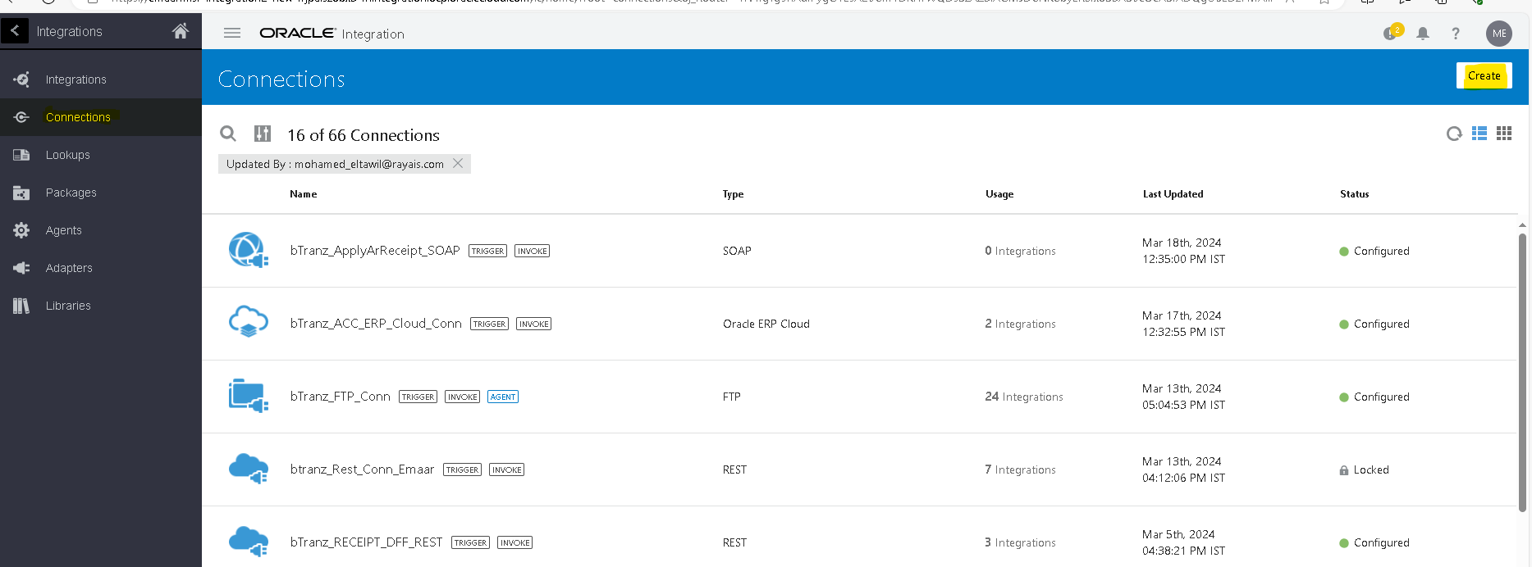
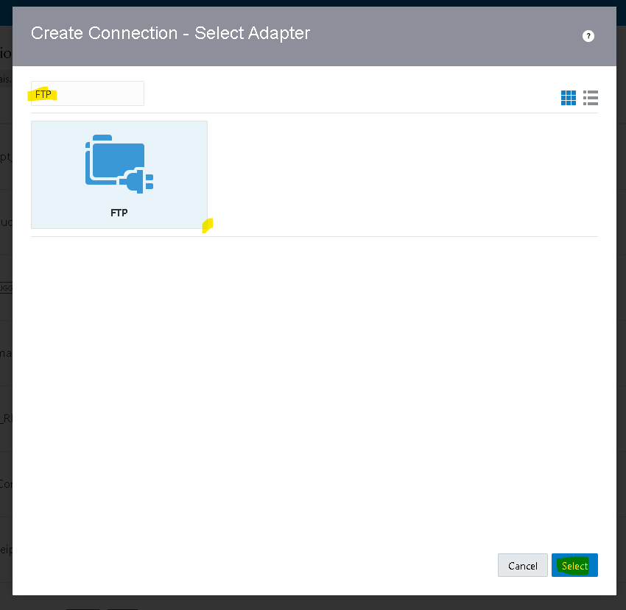
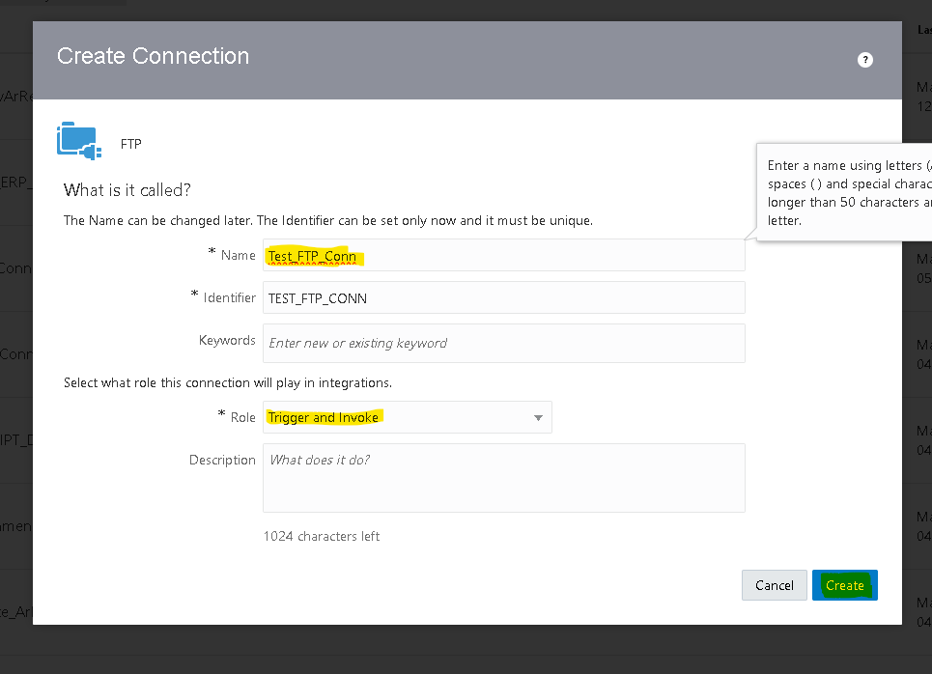

Connection role :- a trigger means the connection where the integration receives the message from. An invoke means the connection where the integration sends the message to.
- Based on our requirement we choose trigger and role connection
- After clicking on create we need to pass the required credentials as shown below
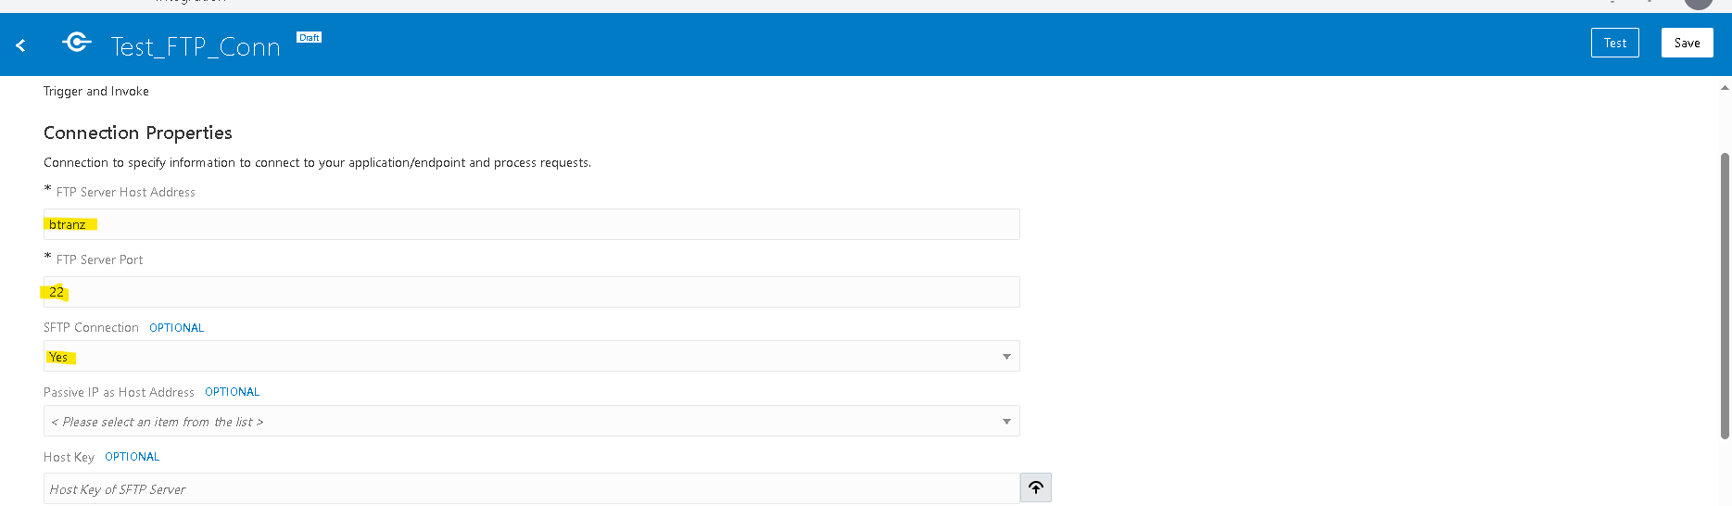
- Then click on test,popup will appear as shown above then select diagnose & test.
- After successful testing save your connection.
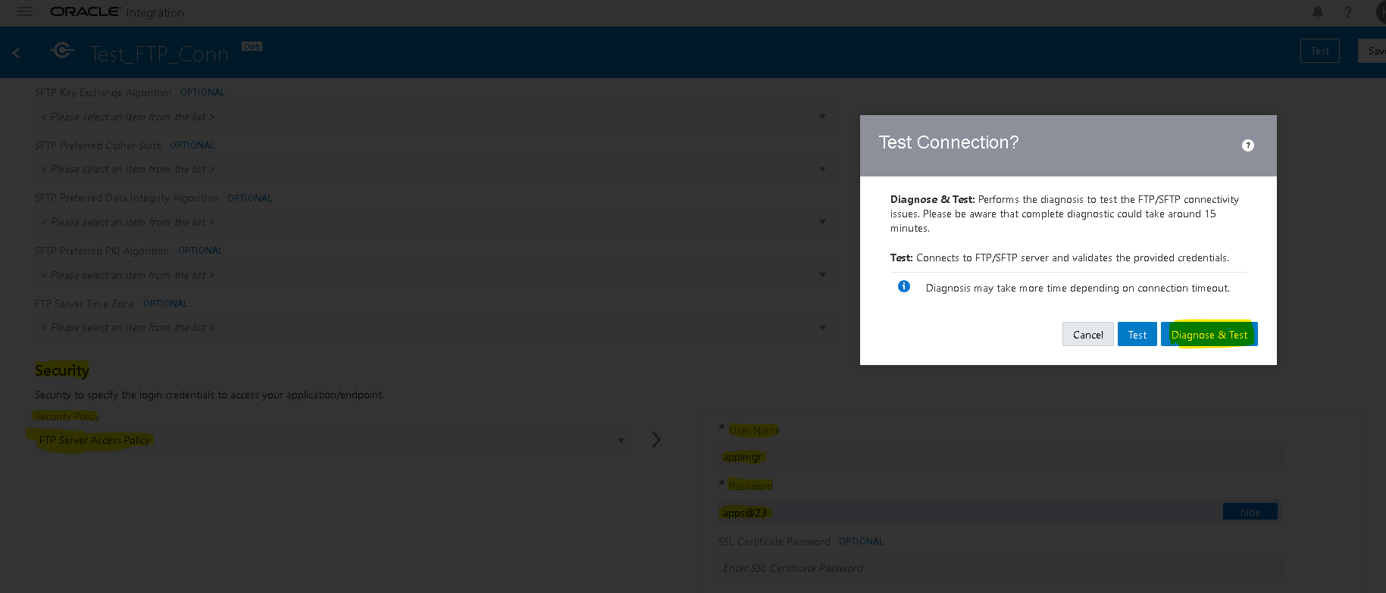
Creation of REST Connection:- Role Trigger And Invoke
- Navigate to connections tab then select the adapter based on the connection(rest)
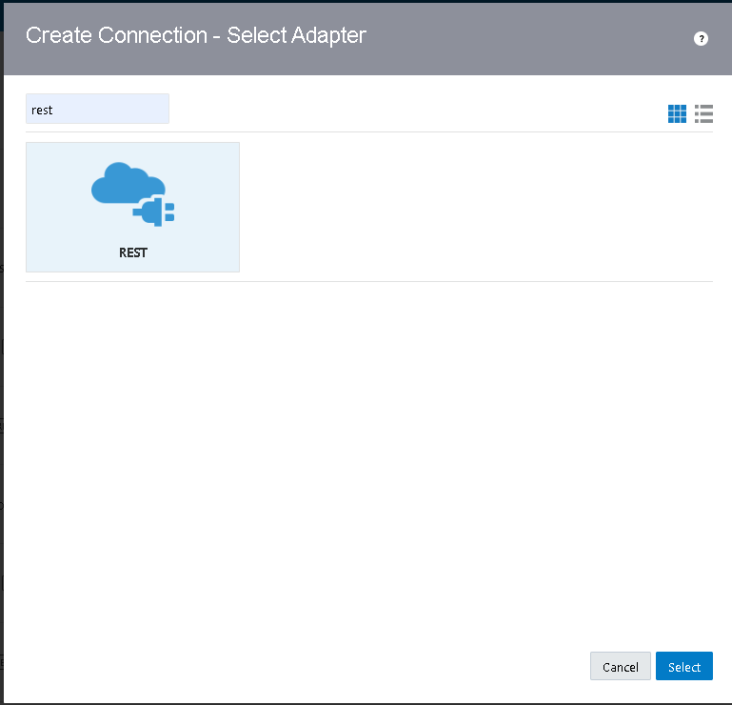
- Select connection type as rest api base url.
- Enter fusion base url as connection url.
- Select security as basic authentication and enter fusion credentails as username and password.
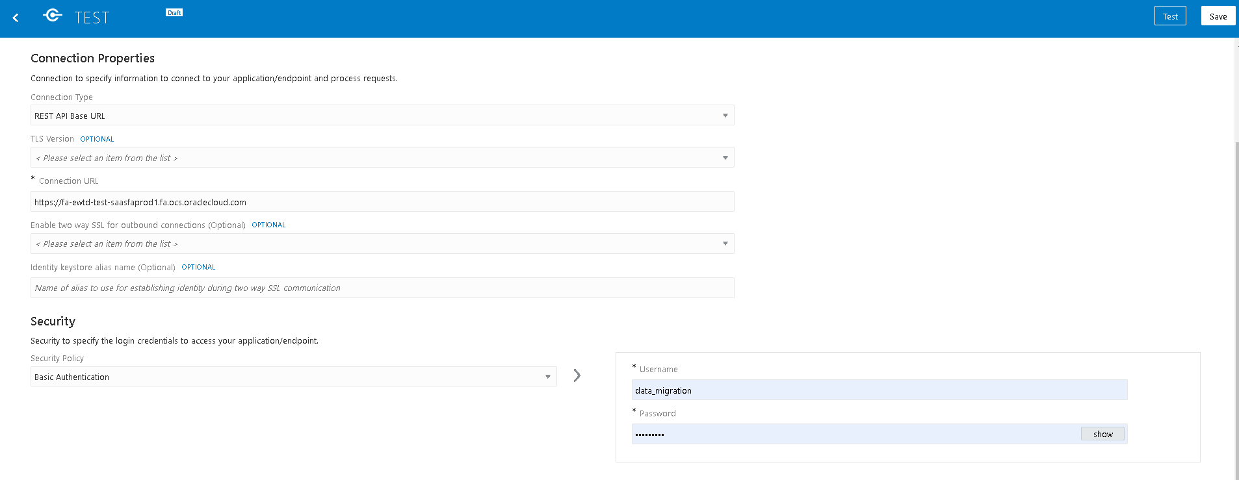
- Then click on test, after testing successfully save the connection.
Creation Of Integration:
- Navigate to integration tab then click on create option and select scheduled orchestration.
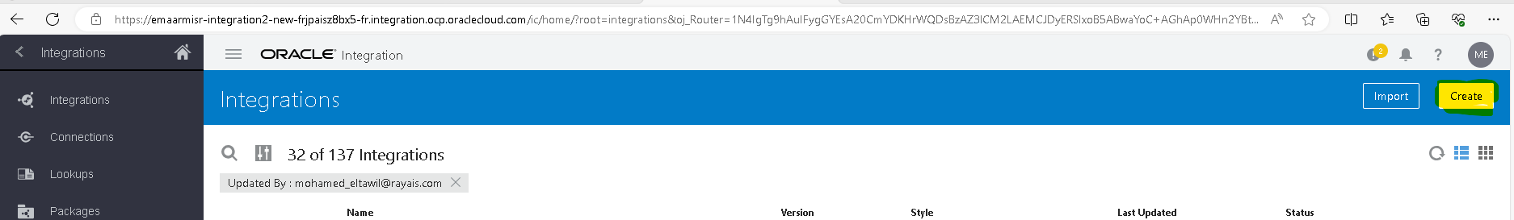
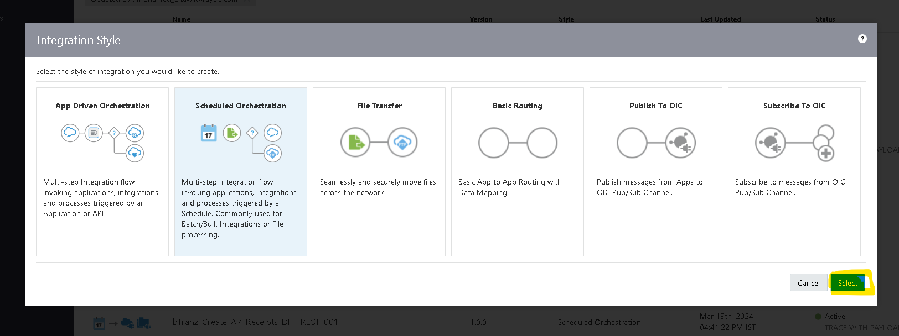

- Try to create with a unique name for identification.
- Once the integration is created select the action button on the right side of the Tab.
- Drag the Assign action and place it on plus (+) icon in the integration.
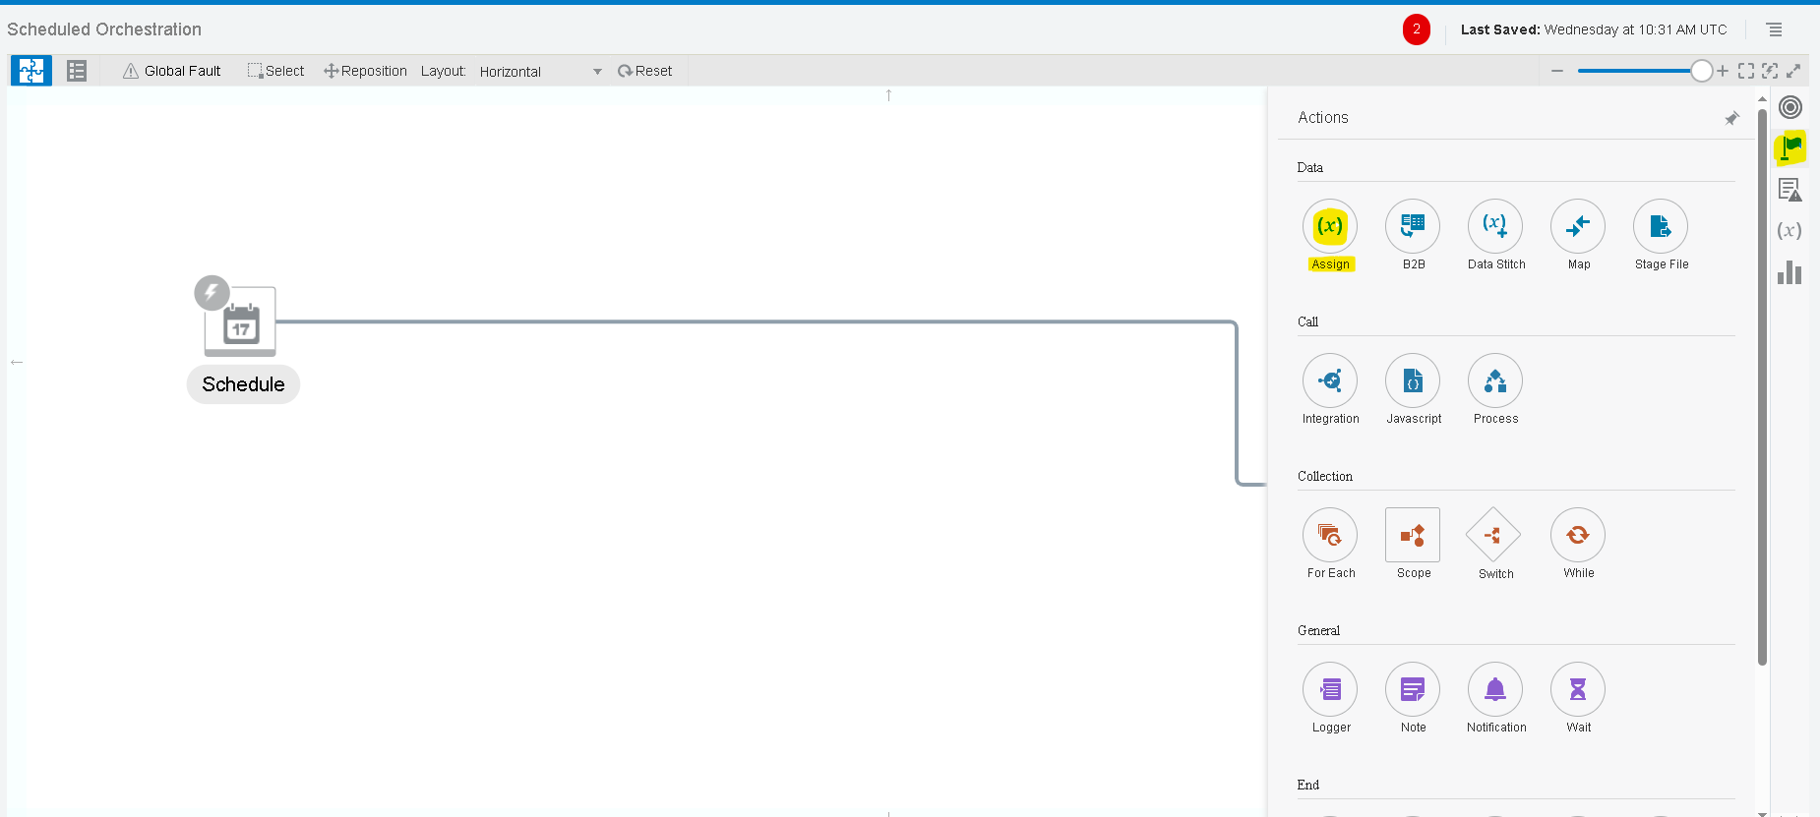
- Give a name for the assign action and click on create.
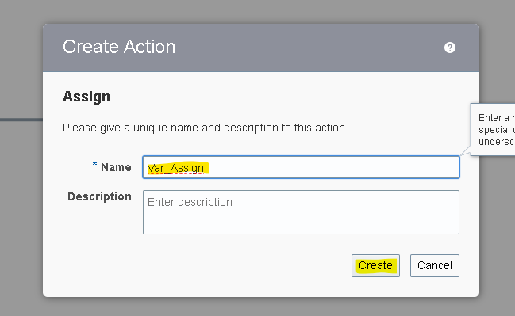
- Give the name of the variable and click on the pencil icon to assign the value for the variable.
- To add one more variable you can select plus (+) icon.
Note :- To Assign/Mention The Values We Need To Use Single Quotes .

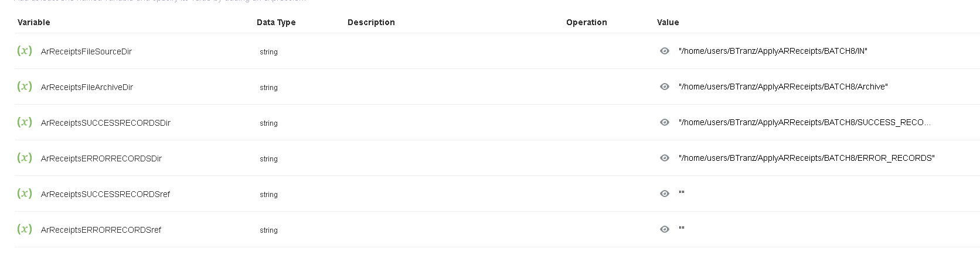
Here we created six variables.
- Var_Lines_SourceFileDir : To store the source file directory.
- Var_Lines_ArchiveFileDir : To store the archive file directory.
- Var_LinesErrorRecords_FTP : To store the error records directory.
- Var_LinesSuccessRecords_FTP : To store the success records directory.
- Var_Lines_SuccessFileRef : To store the success records data.
- Var_Lines_ErrorFileRef : To store the error records data.
- Var_HeaderSuccessRecords_FTP : To store the header success records directory.
- Var_HeaderErrorRecords_FTP : To store the header error records directory.
- Var_Header_SuccessFileRef : To store the header success records data.
- Var_Header_ErrorFileRef : To store the header error records data.

- Select the Plus (+) Icon and select the FTP adapter which we created earlier.
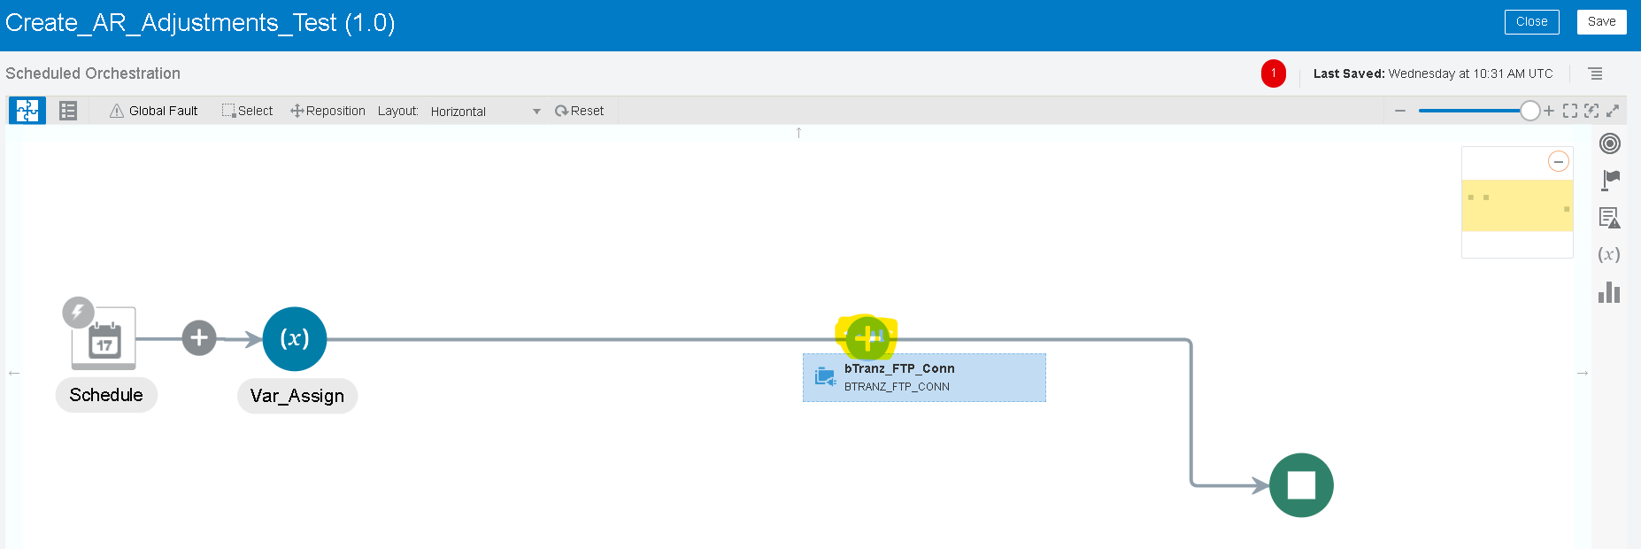

- Name the ftp connection appropriate to your integration for better understanding. As we are listing the number of files in source dir, so we used the List_Files operation.

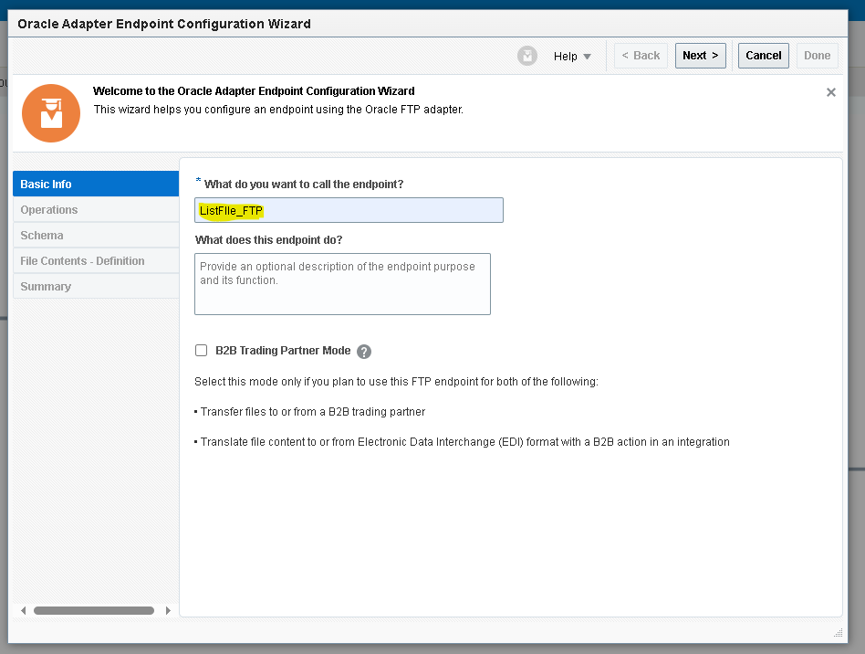
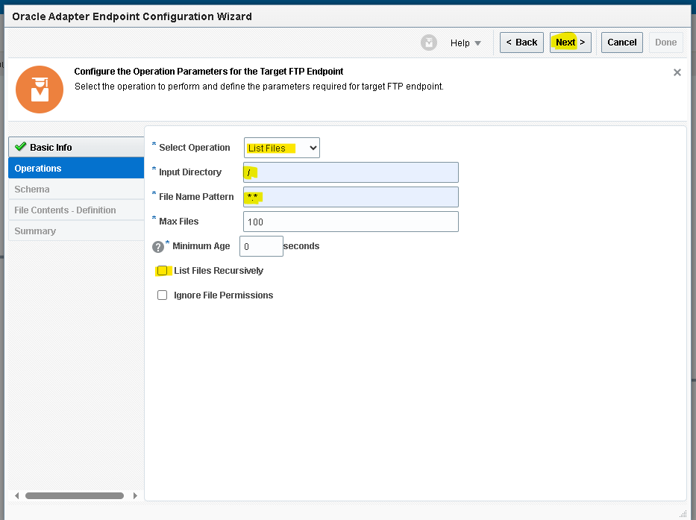
- Since we are using variables for input directory, temporarily mentioned ‘/’ and’ *’ symbols.

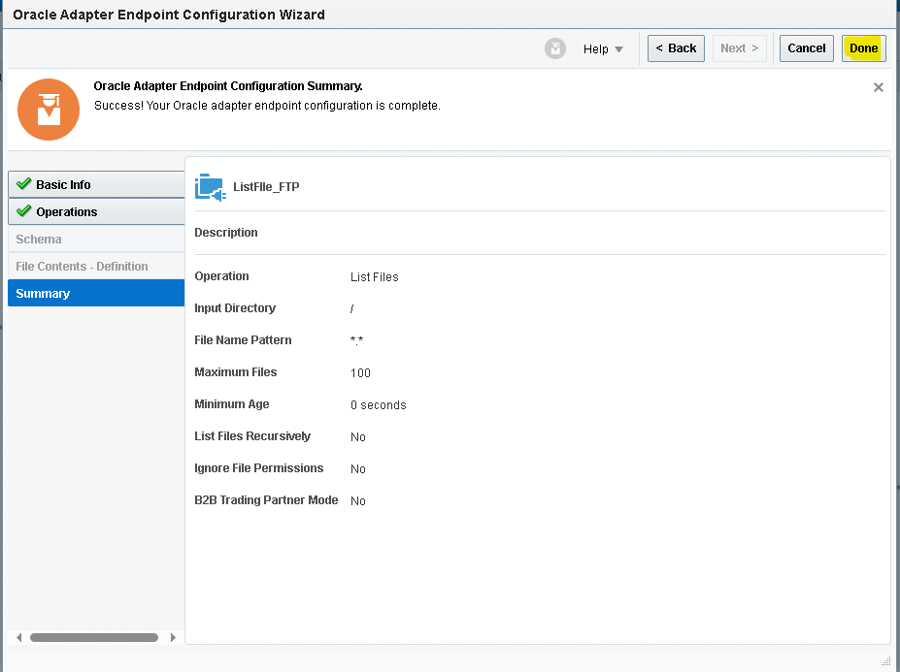
- Then it will create a mapper for ListFile_FTP.
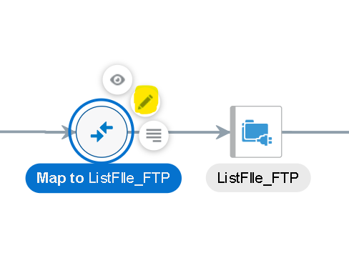
- We need to map the data for the list operation as a request.
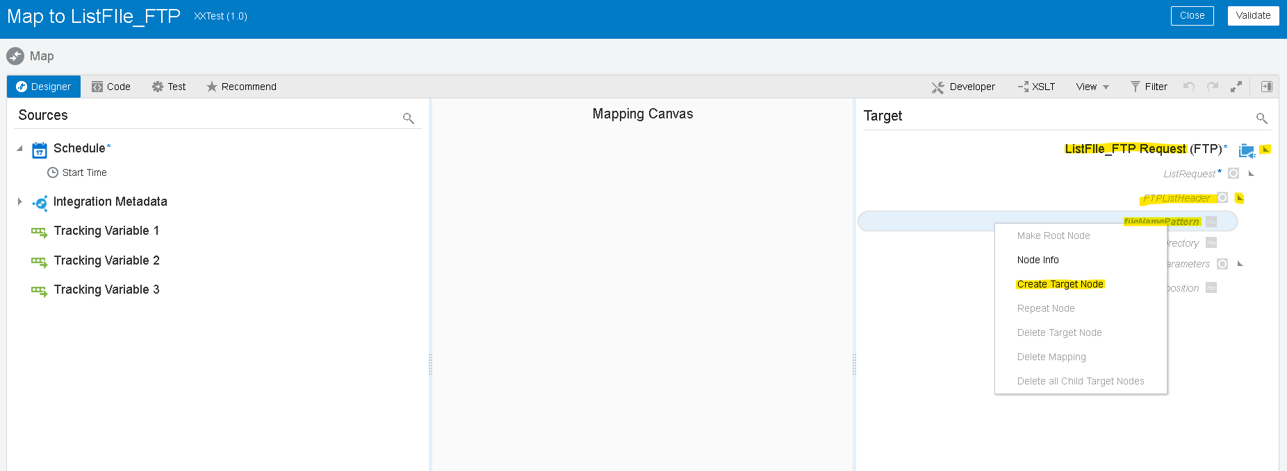
- We need to create a target node if we need to map the data manually as per our requirement.
- Here we are listing every file from the directory so we will use asterisk (*) for the FileNamePattern using single quotes as shown below
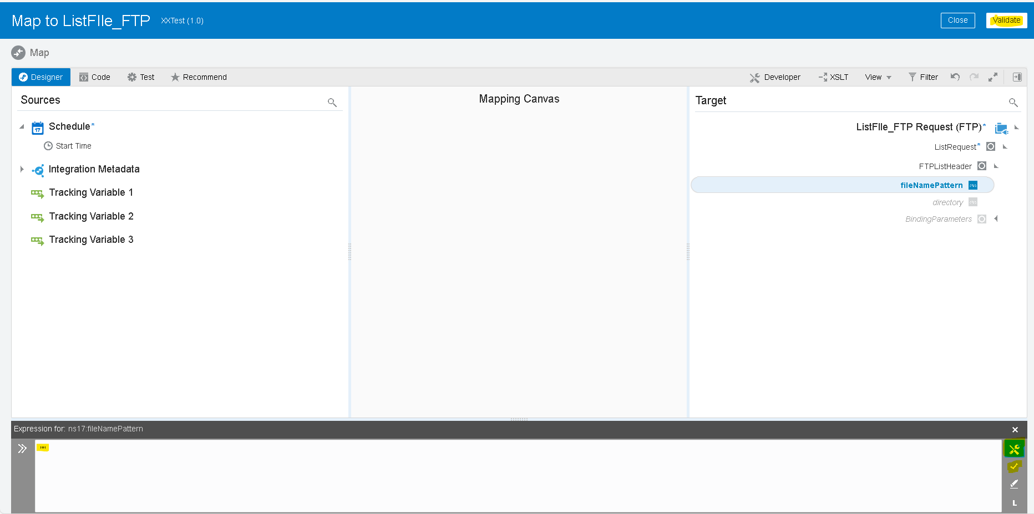

- For the source file directory, we will map the variable which we created before by dragging left to right and click on validate.
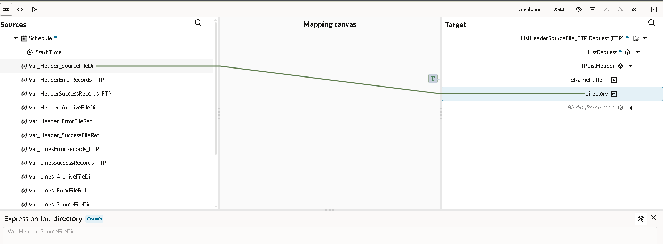
- Do the Same List Operation to list Lines files.
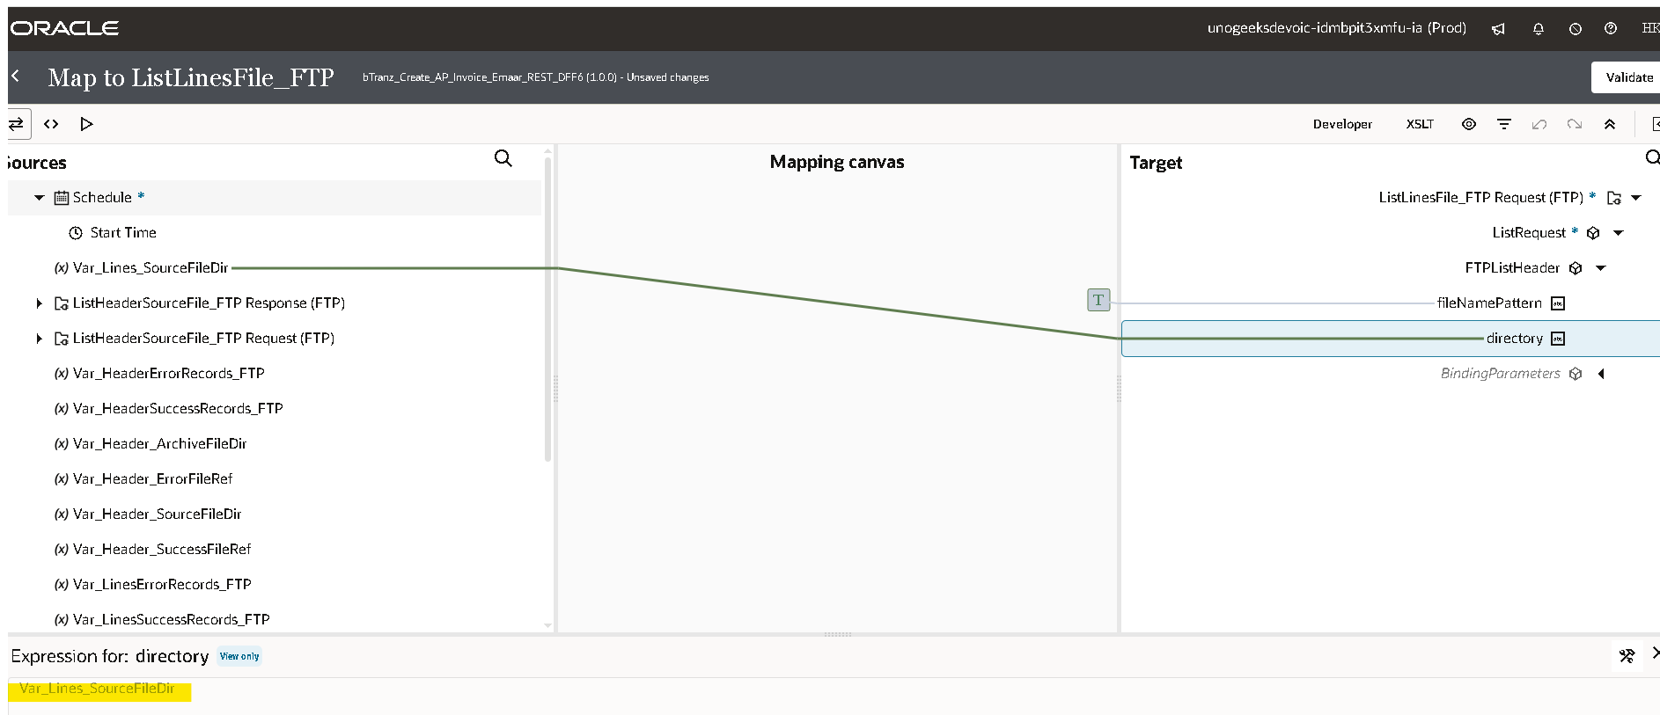
- Now we are using switch operation to check whether file exists or not in the listed directory.
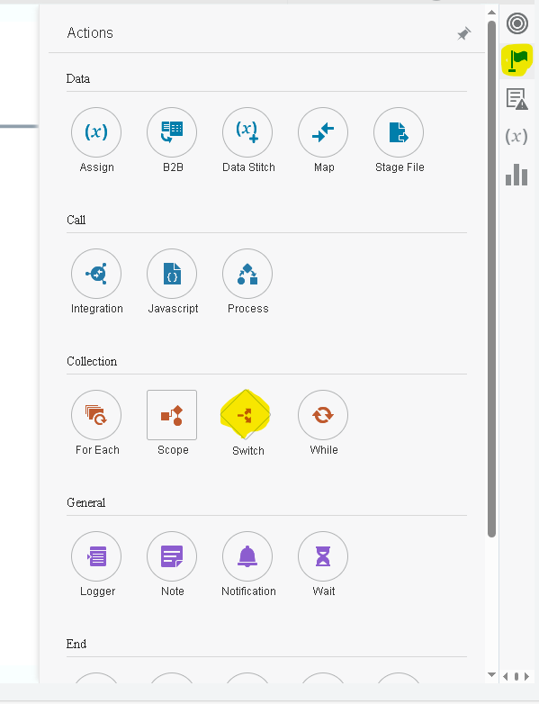
- Once you drag the switch operation on the plus (+) icon
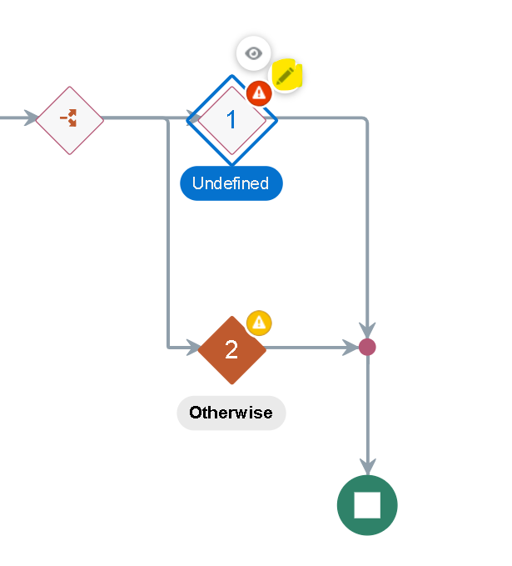
- We will use the response of the ListFile operation using ItemCount.
- Drag the ItemCount from the ListResponse of headers and lines to the switch condition as shown below.

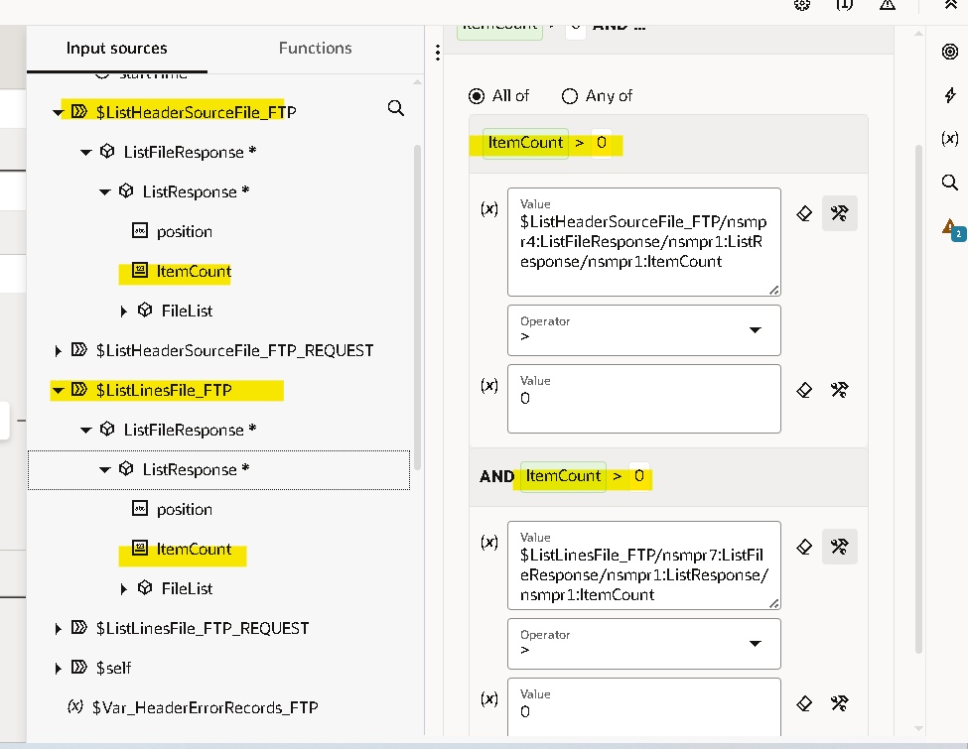

- Now we need to use ‘For Each’ action as we need to iterate each file.
- Click on plus (+) icon and search ‘For Each’ as shown below.
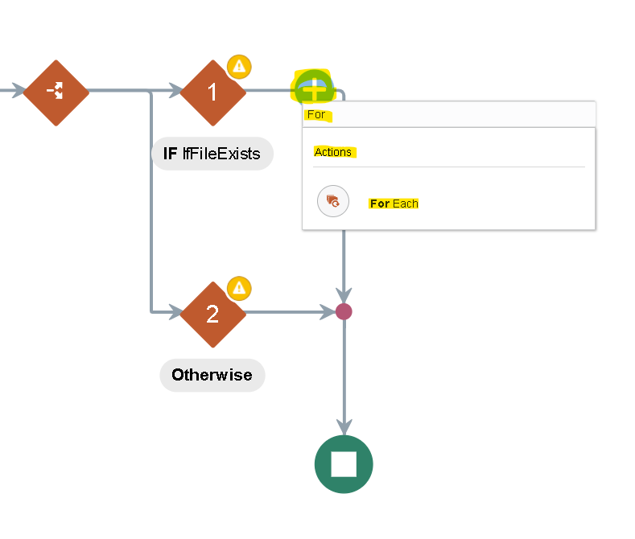
- We will use the repeating element as the file which we got as a response from the list file operation.
- Drag the file to the repeating element and click on create.
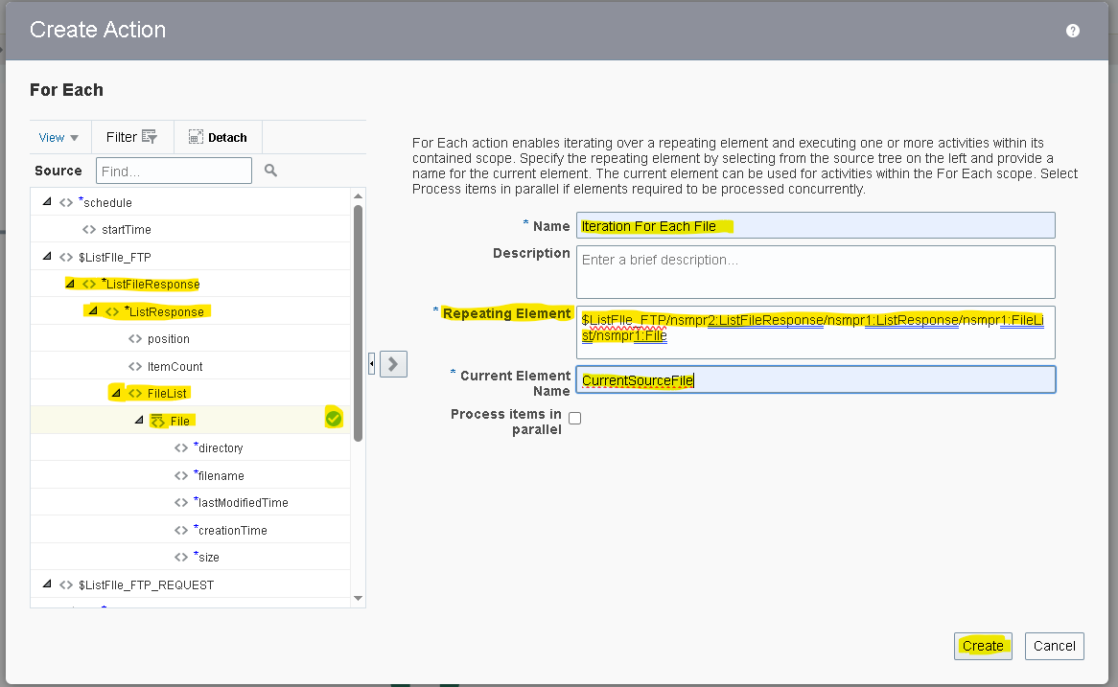

- Scope : - it is a logical container or grouping mechanism used to organize and control the flow of integration components and actions within integration.
- We need to add a scope as we can handle any errors within scope without disturbing whole integration.
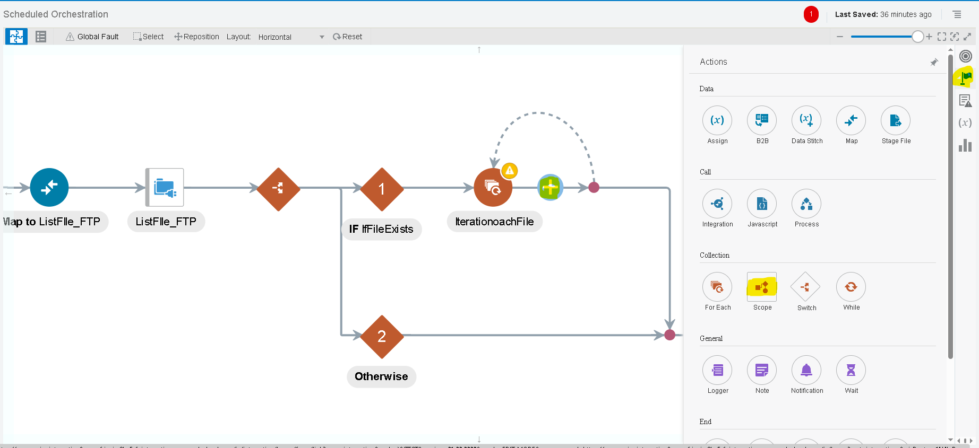
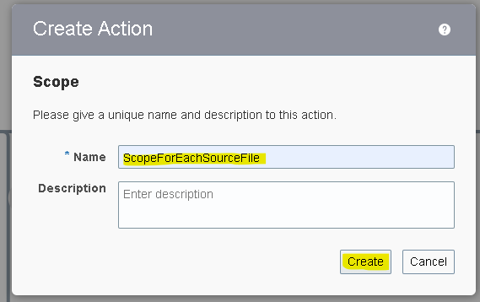
- Within the scope we are using download operation of the ftp connection.
- The download operation allows us to download the file in OIC logical directory. It is the virtual directory which can only be used within that integration.
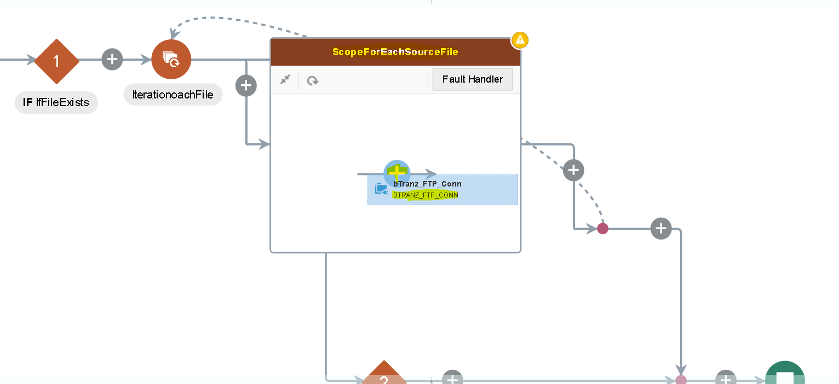
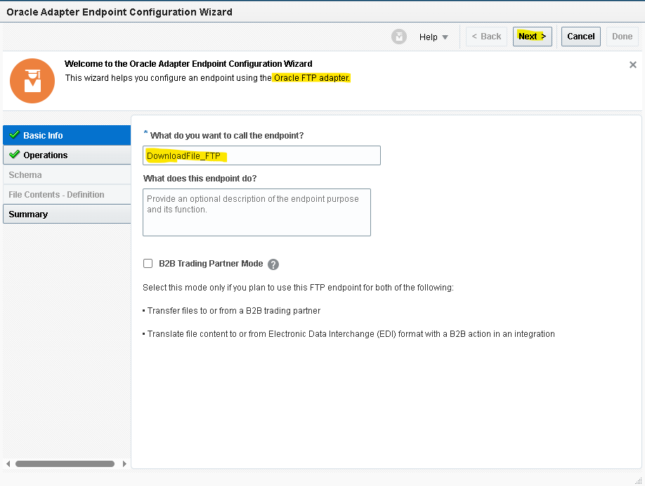

- We will map the input directory and file name later with the response of the ForEach. As of now we are assigning it.
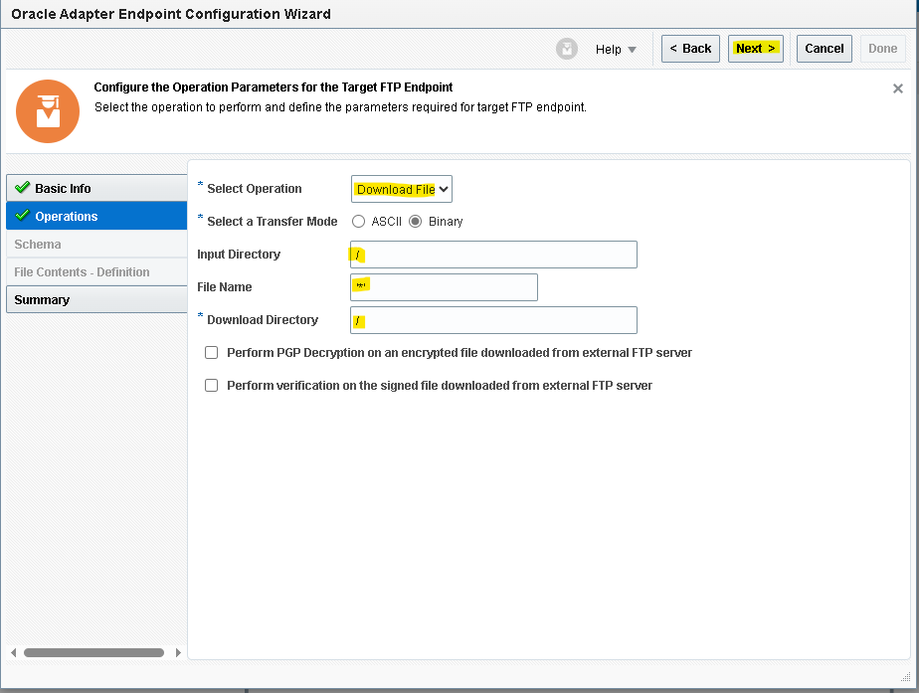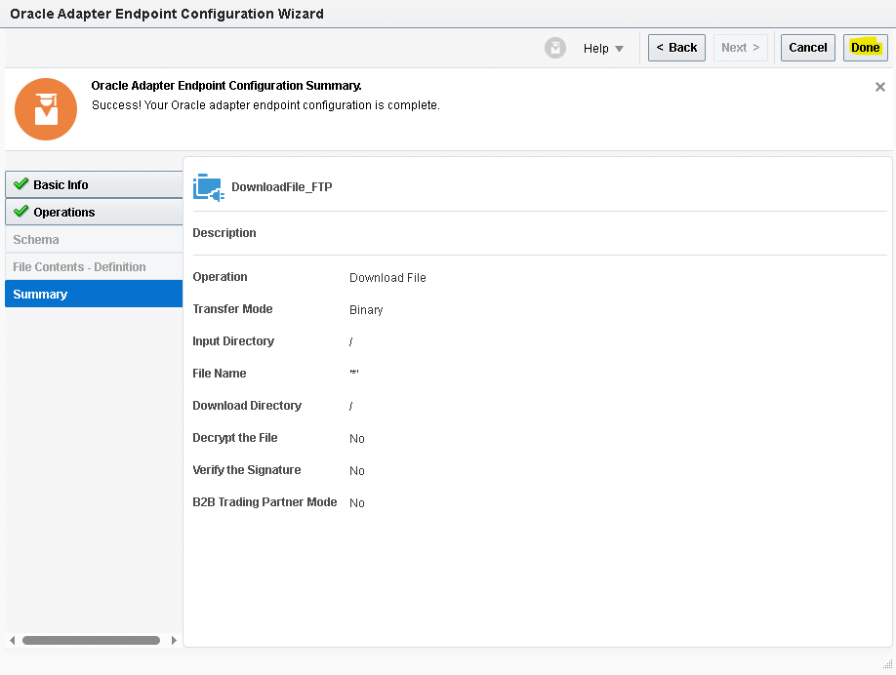
- Click on edit icon on the mapper of the download file operation and map the values.
- For the file name and the directory, we are using the current source file which is the ForEach response.
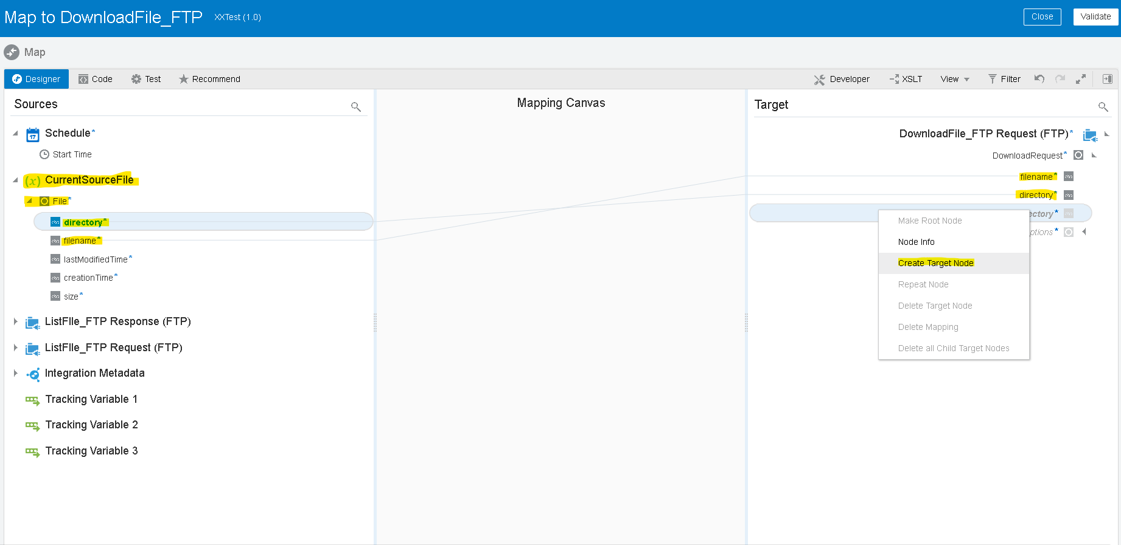

- For download directory (OIC logical directory) we are using the filename .here we are using the substring before function to remove the .extension and returns only file name.
- Drag the substring option from the toggle function option from the top right corner as shown above
- Drag the filename from the current source file and hardcode the mapper as it returns the string before the dot (.) And then validate.

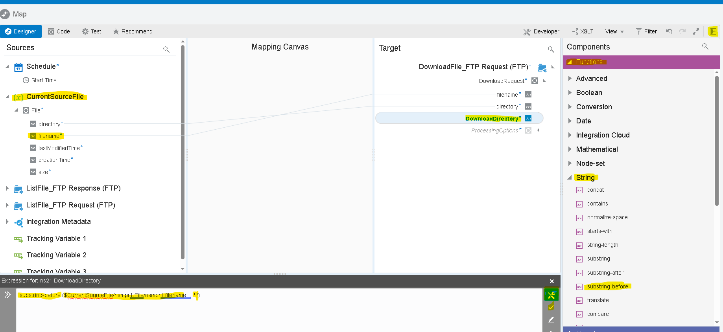
- Do the same to download the Lines files and store in stage directory.
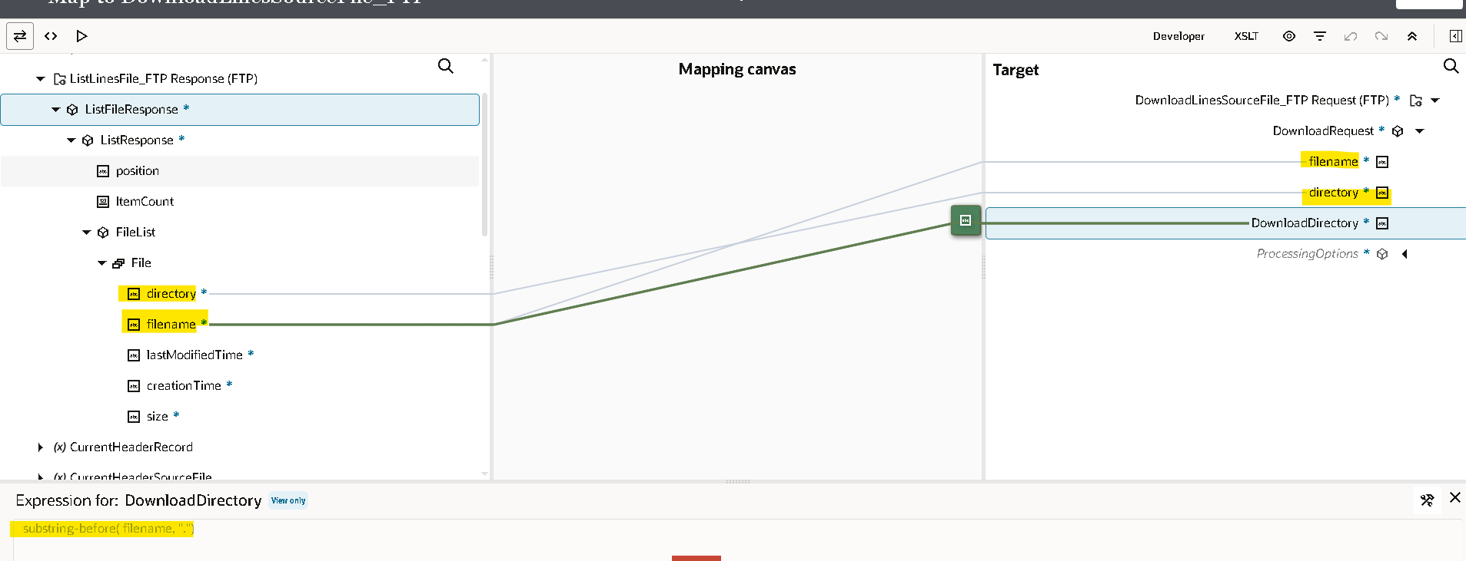
- Now we will use the stage activity to read the file from the response of the source file Download_Ftp.
- Search for ‘stage’ adapter by clicking on the plus (+) icon.
- Select the operation as ‘read File In Segments’. And configure file reference as yes.
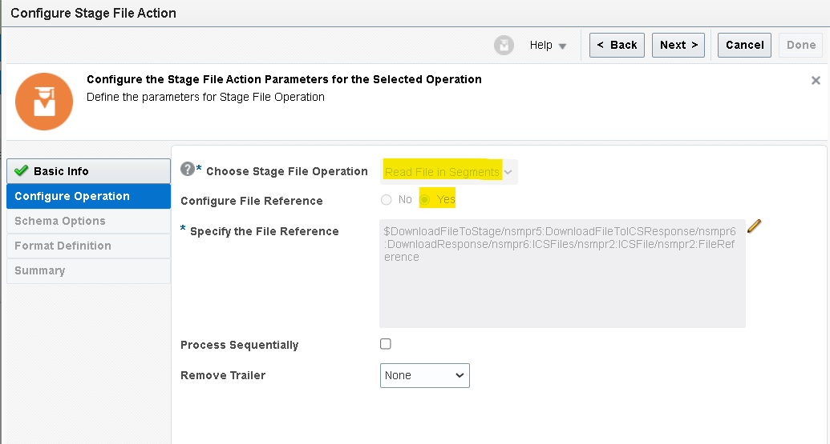
- Now we need to give the structure of the file content. As we are using the csv file select reference file from download response.

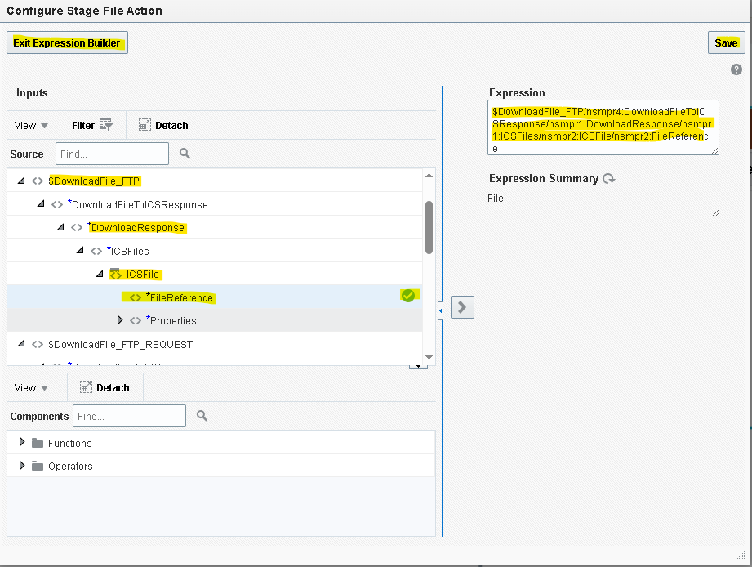
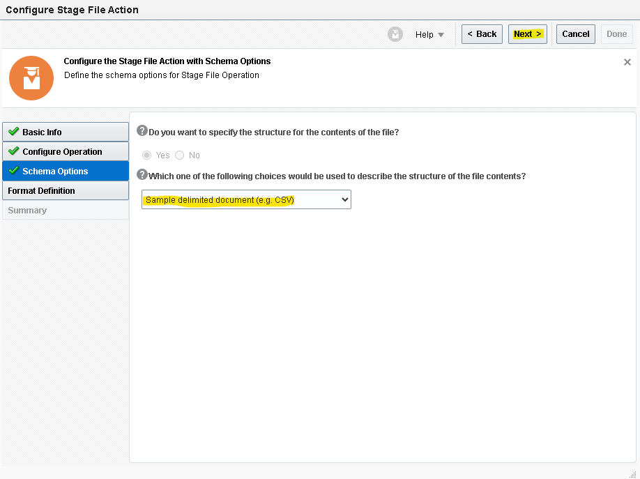
- We need to give sample structure format of the file which we will be downloaded from the ftp.
- Here chooses the file from your local desktop and you can mark all as optional but at least one column should be mandatory.
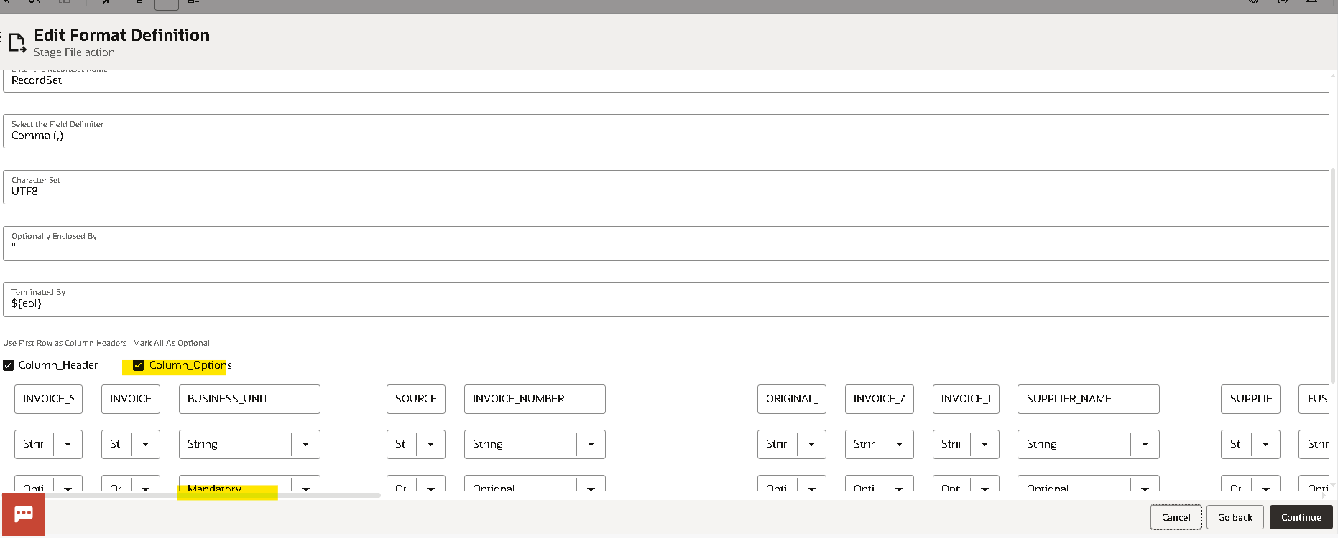

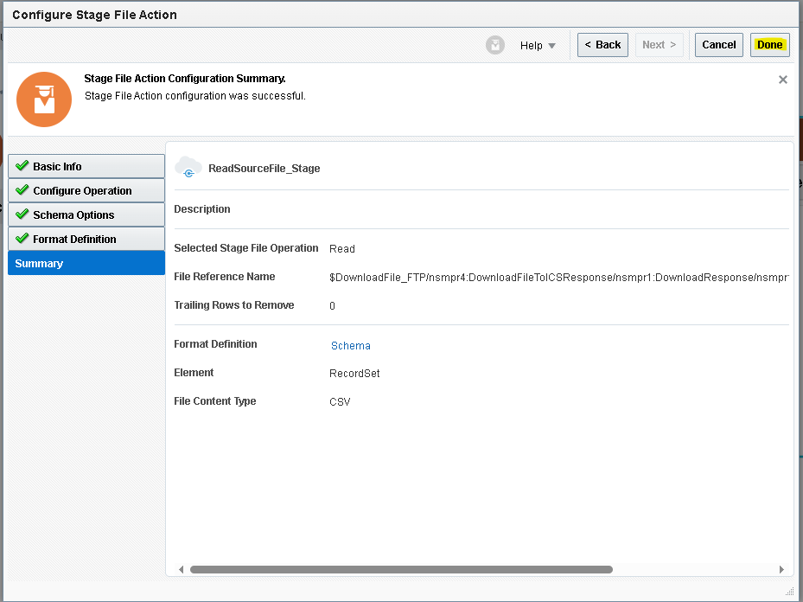

- Do the same to read the Lines Download file but select operation as Read Entire File as Operation.
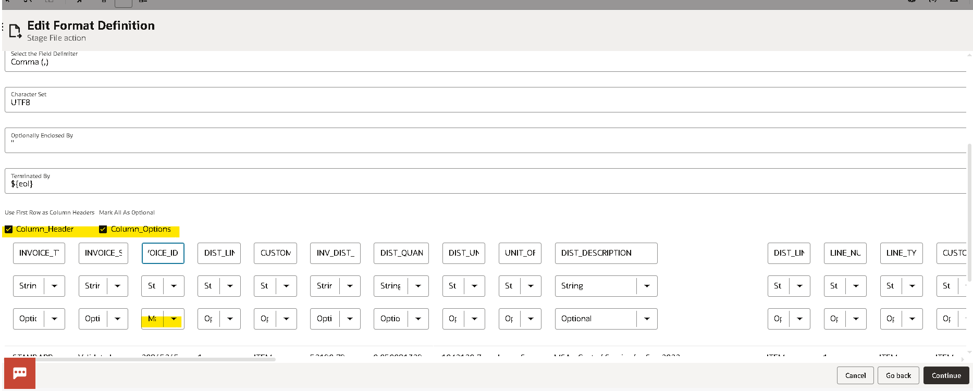
- Use scope to handle errors thrown by rest API.
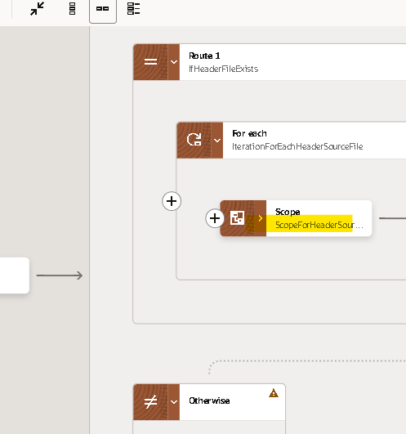
- Use for loop to iterate for every record of headers read as segment response.
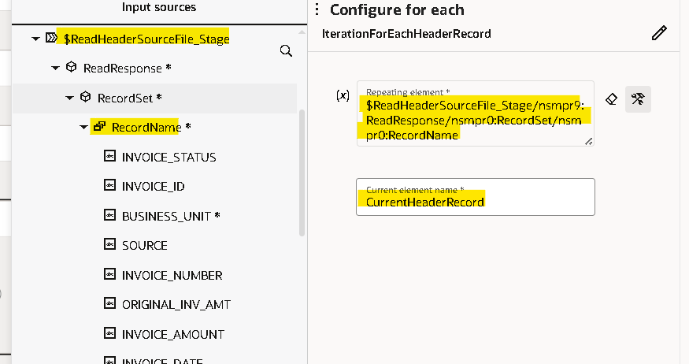

- Use rest adapter to send payload to the fusion.
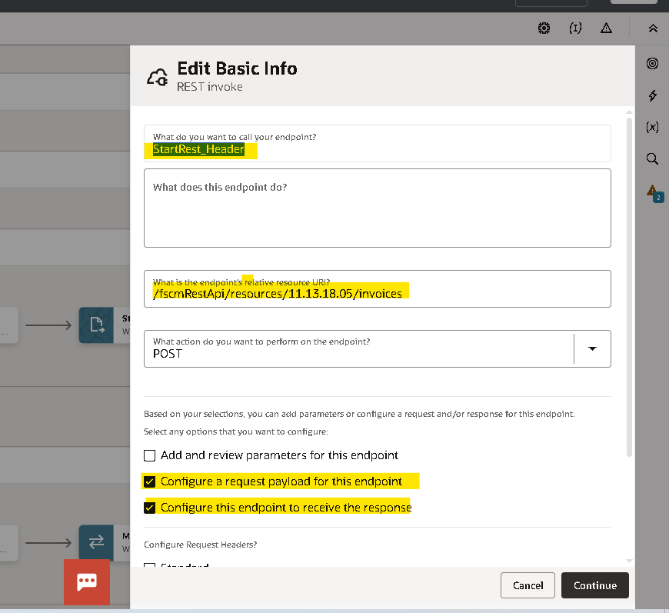
- Provide the Name for the end point , Paste the URI to Create AP Invoices and check the request and response check boxes to configure request and response.
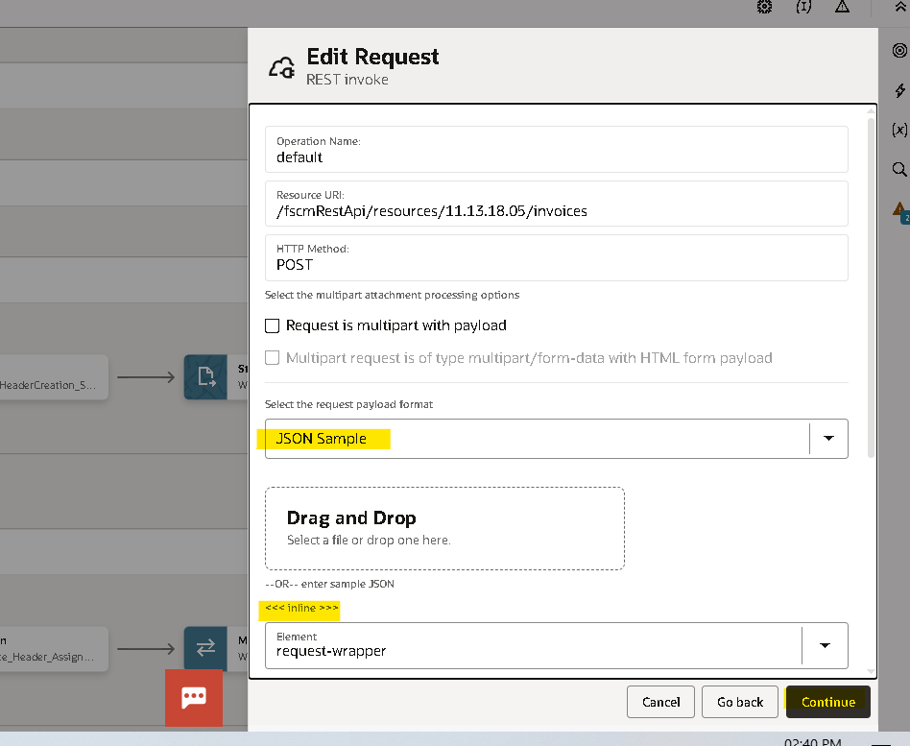
- Select the Request Format as JSON and paste the request payload.
[ {
"AccountingDate" : "22-04-24",
"BusinessUnit" : "qqq",
"ConversionDate" : "02-04-24",
"ConversionRate" : "qq",
"ConversionRateType" : "uu",
"Description" : "yyy",
"InvoiceAmount" : "99",
"InvoiceCurrency" : "uu",
"InvoiceDate" : "02-04-24",
"InvoiceNumber" : "1",
"InvoiceSource" : "aaa",
"InvoiceType" : "aaa",
"LegalEntity" : "111",
"LiabilityDistribution" : "111111",
"PaymentCurrency" : "aa",
"PaymentMethod" : "qqq",
"PaymentMethodCode" : "qqq",
"PaymentTerms" : "qqqq",
"ProcurementBU" : "qq",
"PurchaseOrderNumber" : "",
"Supplier" : "aaa",
"SupplierSite" : "aaaaaa",
"TermsDate" : "20-04-24",
"invoiceDff" : [ {
"voucherNumber" : "aaa",
"invoice" : "aaa",
"conversionType" : "aaa",
"invoiceWhtAmount" : "aaa",
"__FLEX_Context" : "Invoice_Flex",
"supplierName" : "aaa",
"supplierNumber" : "111",
"requestNumber" : "111",
"poNumber" : "111",
"invoicePhysicalFileLocation" : "aaaa",
"invoiceReceivedDate" : "02-04-24",
"documentFlag" : "Y",
"invoiceType" : "",
"materialInSiteAmount" : "111",
"reimbursableAmount" : "111",
"invoiceIds" : "1111",
"documentNumber" : "111",
"invoiceNumber" : "111",
"receivedDate" : "02-04-24",
"holdReason" : "qqq",
"description2" : "qqqq",
"updatedReceivedDate" : "02-04-24",
"unifierRecordId" : "111",
"unifierRecordNo" : "111",
"uniferProcessName" : "aaaa",
"unifierProcessId" : "111",
"unifierProjectId" : "1111",
"unifierGrossAmount" : "111"
} ],
"invoiceLines" : [ {
"AccountingDate" : "22-04-24",
"Description" : "a",
"DistributionCombination" : "77777",
"LineAmount" : "q",
"LineNumber" : "q",
"LineType" : "q",
"PurchaseOrderLineNumber" : "1",
"PurchaseOrderNumber" : "111",
"PurchaseOrderScheduleLineNumber" : "11",
"Quantity" : "777",
"UnitPrice" : "777",
"invoiceLineDff" : [ {
"invoiceWhtLineType" : "null",
"projectNumber" : "null",
"taskNumber" : "111",
"expenditureType" : "qqq",
"__FLEX_Context" : "Invoice_Lines_Flex",
"subContractor" : "aaa",
"taxId" : "111",
"taxRegister" : "111",
"costType" : "aaa",
"unifierProjectId" : "111",
"unifierProcessId" : "111",
"unifierRecordId" : "111",
"unifierRecordLineId" : "111",
"unifierLineType" : "aaa",
"poNumber" : "111",
"unifierPoRecordLineId" : "111",
"project" : "aaa",
"unite" : "aaa",
"transactionType" : "aaa",
"packageCode" : "111",
"parcel" : "aaa",
"ref" : "aaa"
} ]
} ]
} ]
- Do the same with response and provide the sample payload.
{
"InvoiceNumber" : "INV_1112222",
"InvoiceId" : "555588779",
"AccountingDate" : "2024-04-01"
}
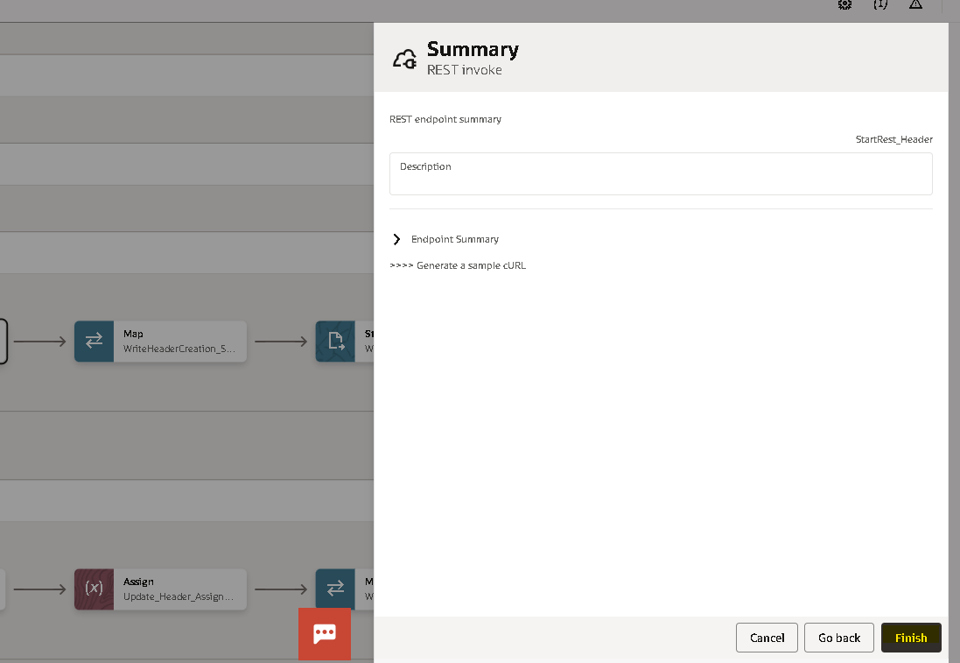
- Click on Finish mapper will generate automatically.
- Map the header source records and lines records with target headers, DFF and lines records as shown in the mapper.
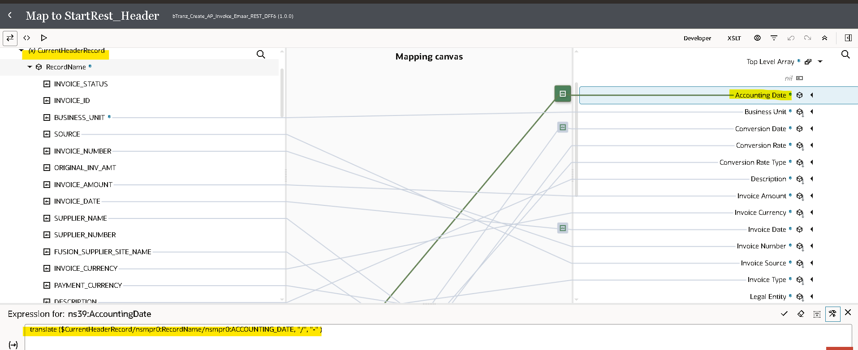
- Translate function is used to translate ‘/’symbol from source data and it replace with’-‘ symbol in accounting date. translate ($CurrentHeaderRecord/nsmpr0:RecordName/nsmpr0:ACCOUNTING_DATE, "/", "-" )
- Map the repeating element of read lines response with request Lines and line DFF.
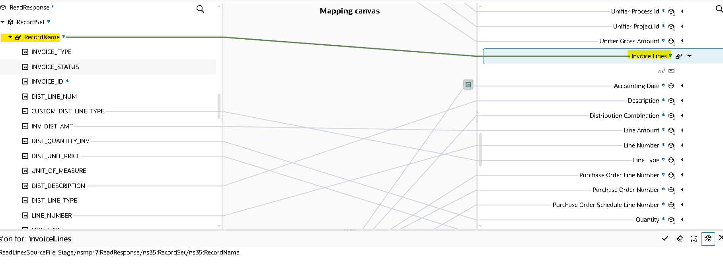
- Click on Validate and close.
- we are using the stage write operation of the stage activity to update the FileReference variable with status and Error_Message columns.
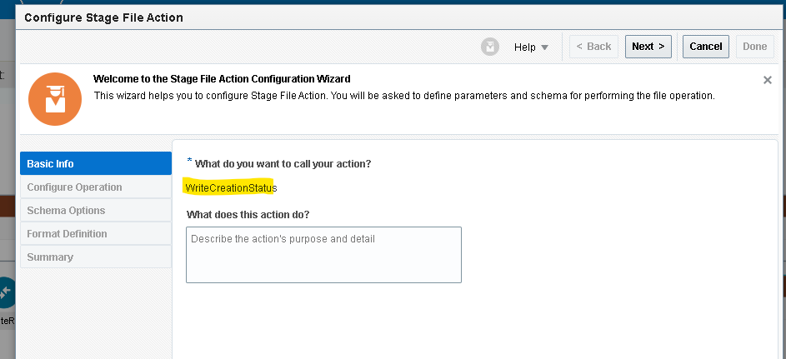
- Choose the file operation as writefile.
- Specify the file name and output directoty to store the file tempararly.
- Here we are using the option append to existing file which appends the every record to the file.
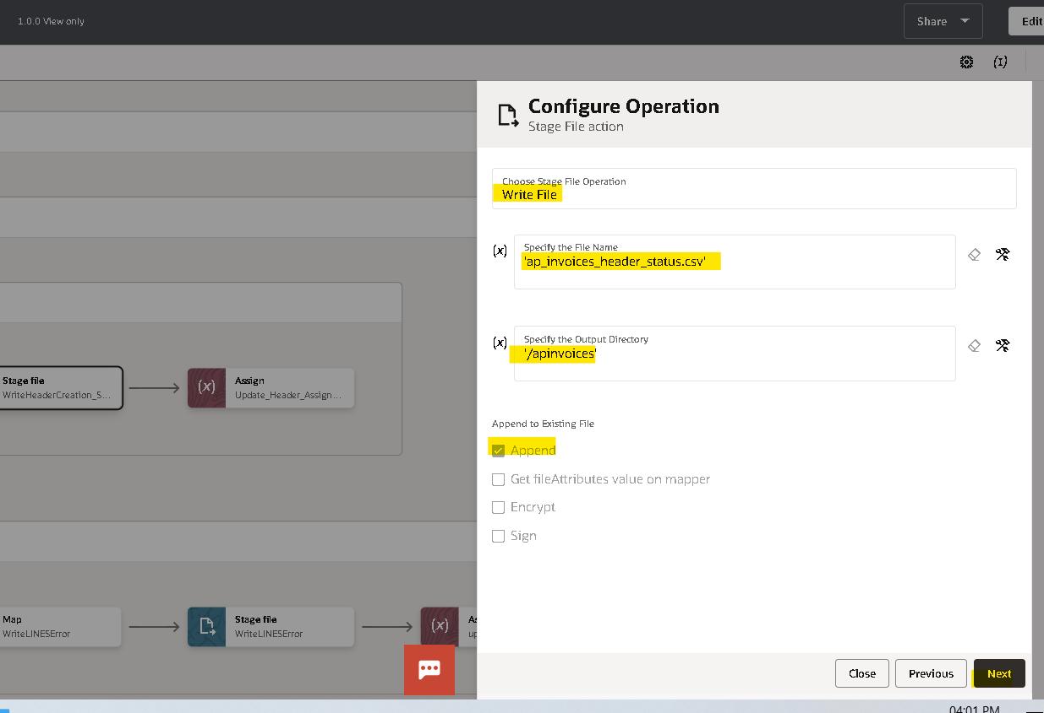
- Now we need to provide the structure of the file content here we are added two more columns in this file structure with ‘status and error message’.
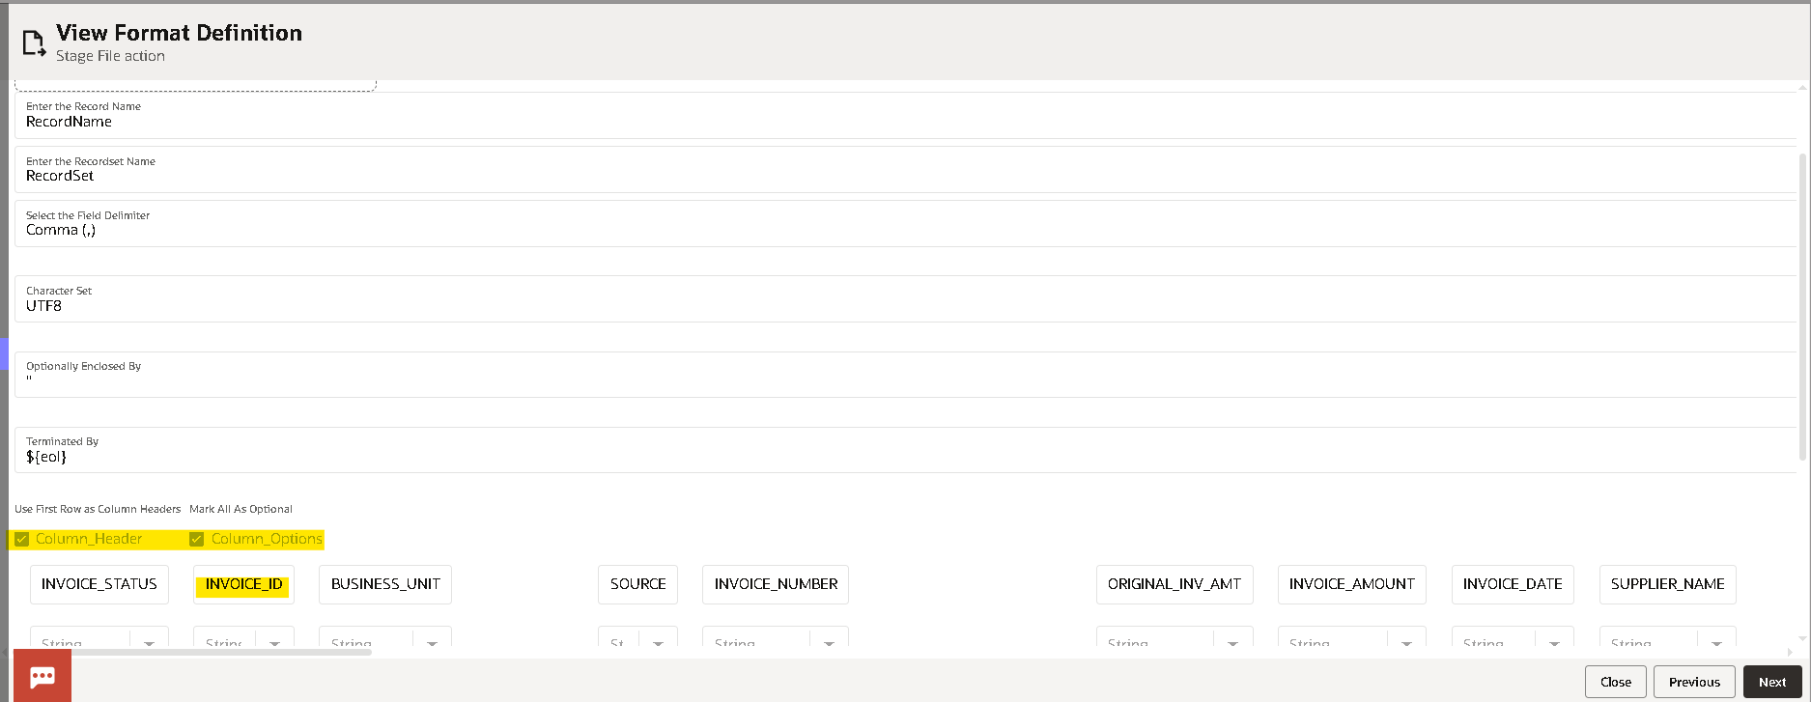

- Check the configuration and click on done.
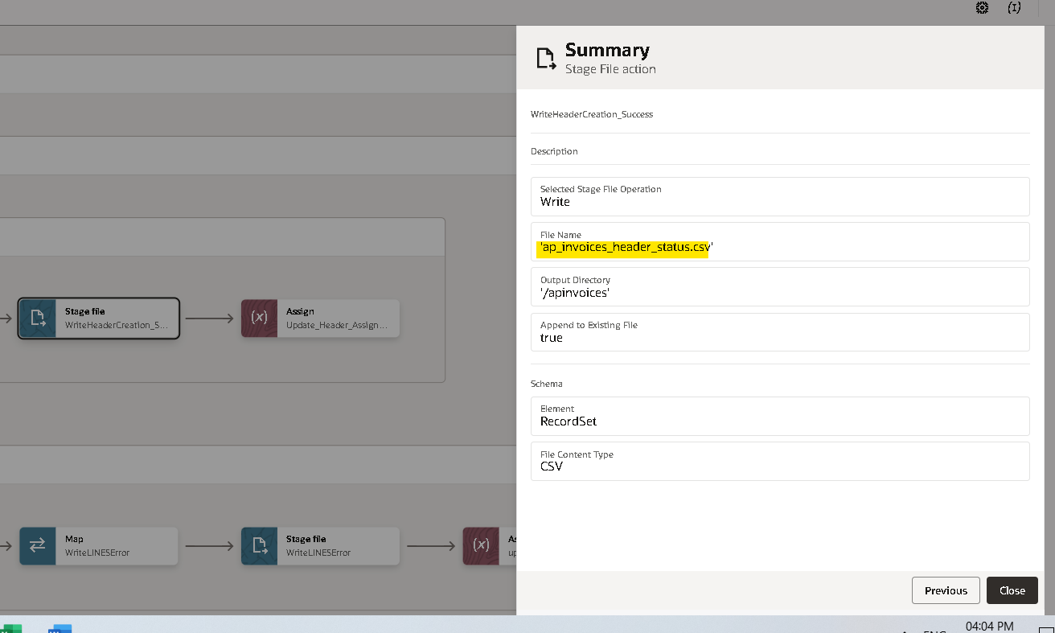
- Now edit the mapper of ‘writeHeader creation status’ map the current record columns to target fields and create a target node for the column status and hardcode with success.
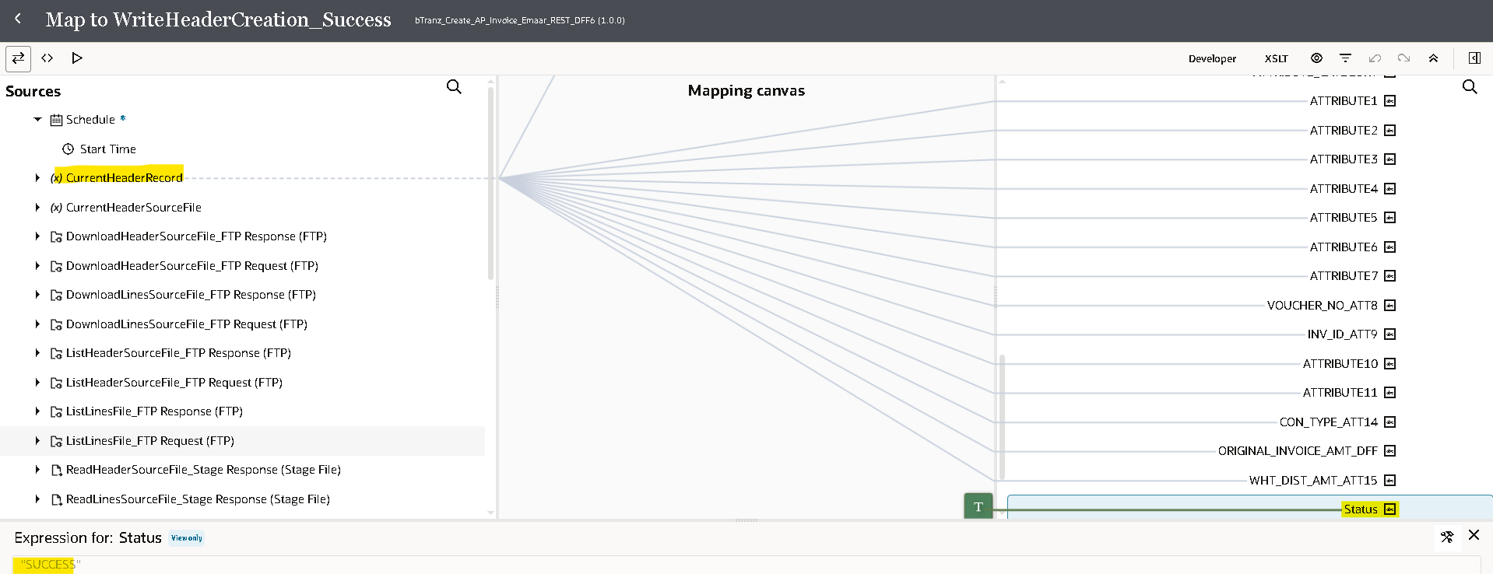
- Now we will update the Var_Header_SuccessFileRef variable with the response of the WriteFile_Stage operation by using assign activity
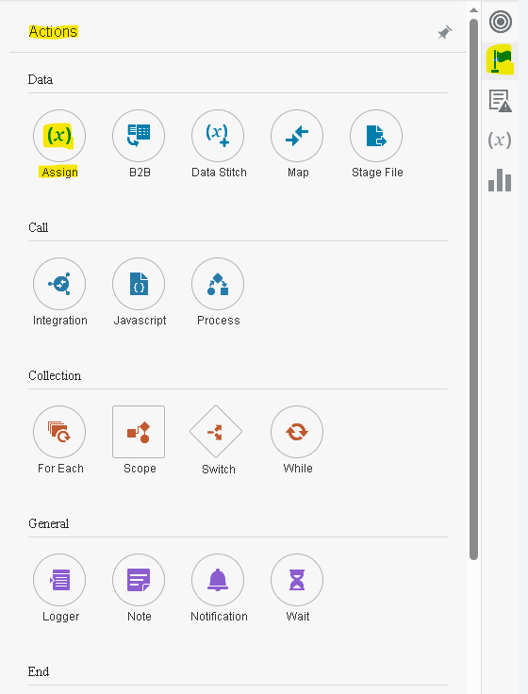
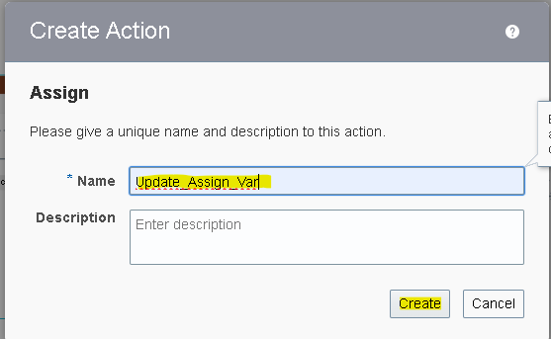
- By clicking on plus(+) icon it will create a variable then from the drop down select the variable which we want to update
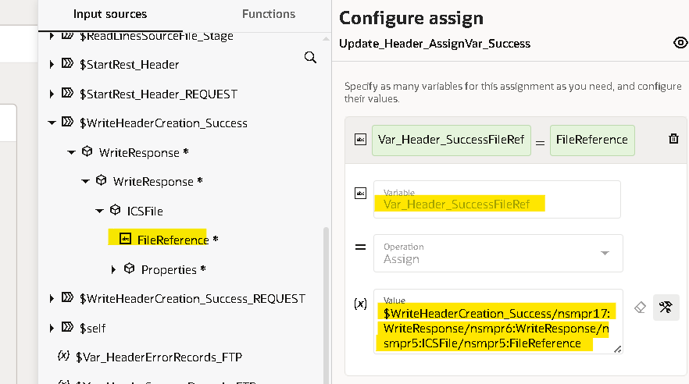

- Assign the FileReference from WriteHeaderCreation_Success response.
- In Fault Handler use the stage write to write the error. (as done before for the success case) with status as ‘error’ and for error message we will map details of the ScopeForeEachRecordFaultObject details.
- Here we used substring function to get required part from error details.
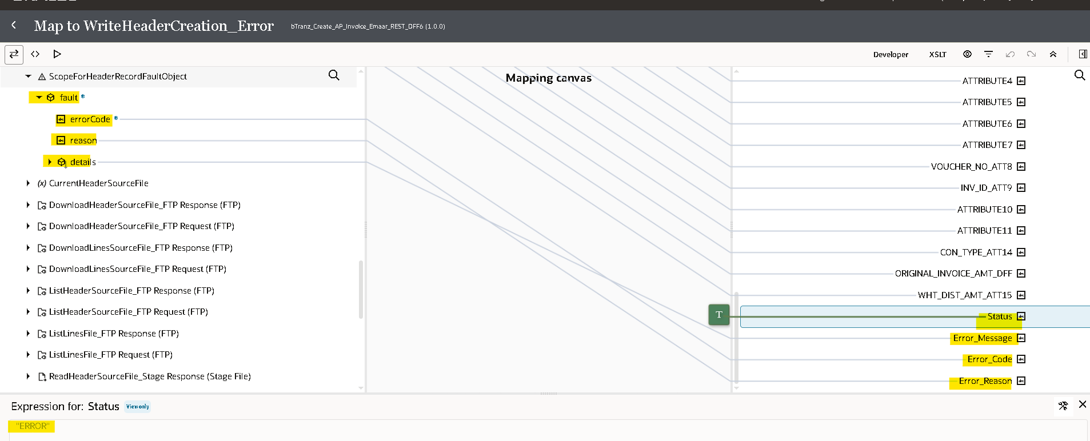
- Create a assignment variable and update the Var_Header_SuccessFileRef variable With FileReference of WriteHeaderCreation_Error response.
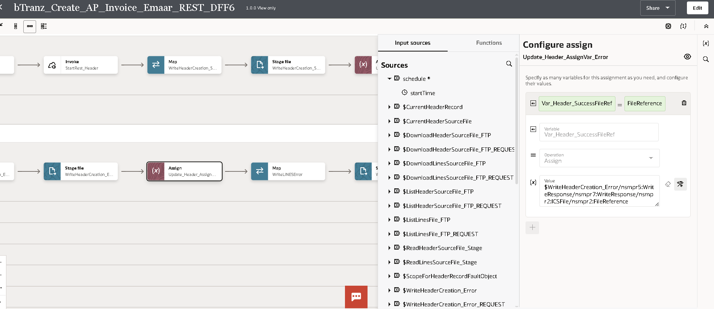

- Repeat the same Write error again to write Lines data and assign reference to the var_line_ErrorFileRef.
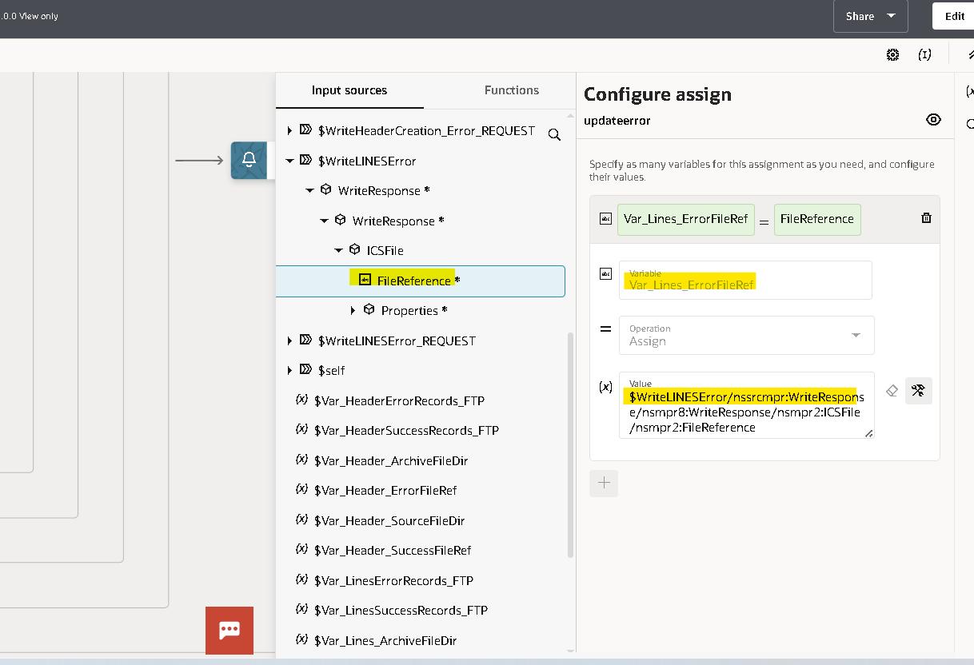

- Now we will use the notification activity to send a mail in message body we will send the InstanceId of the integration and Filename.
- Drag the notification action on the outside of both the scopes.
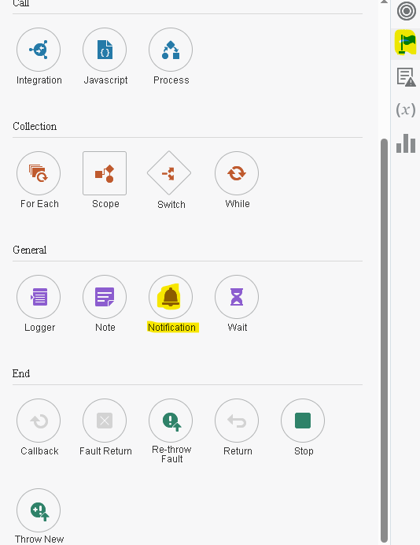
- You can provide the details as per your requirement.
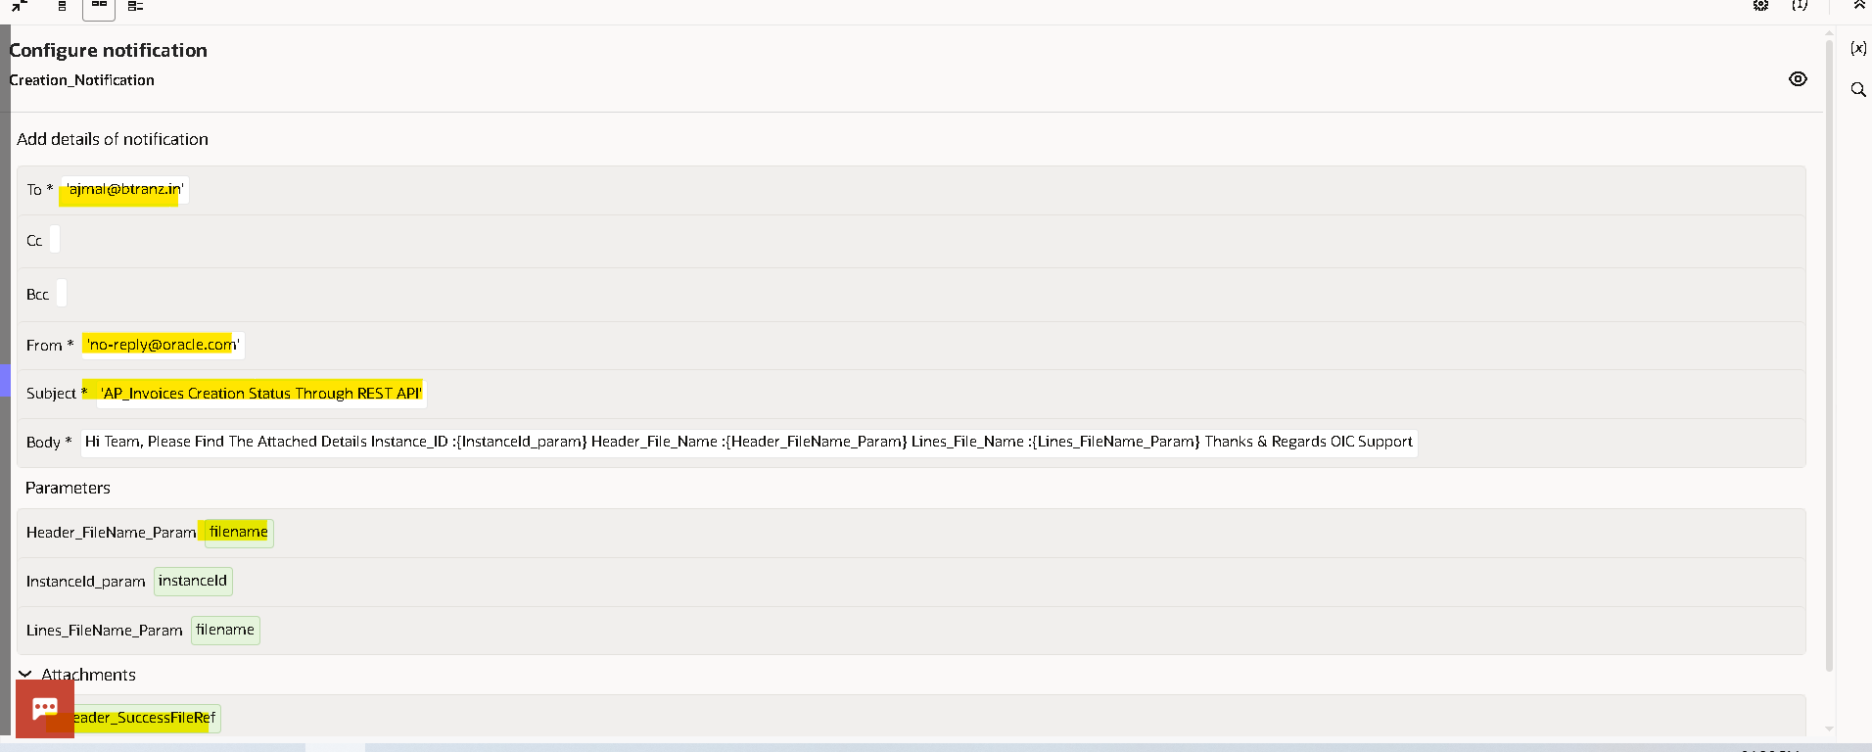
- In message body if you need to pass the InstanceId and filename you need to create a parameter and then you can use those parameters by enclosing with flower brackets as shown below.
- Once you enter all the details validate and close the notification.
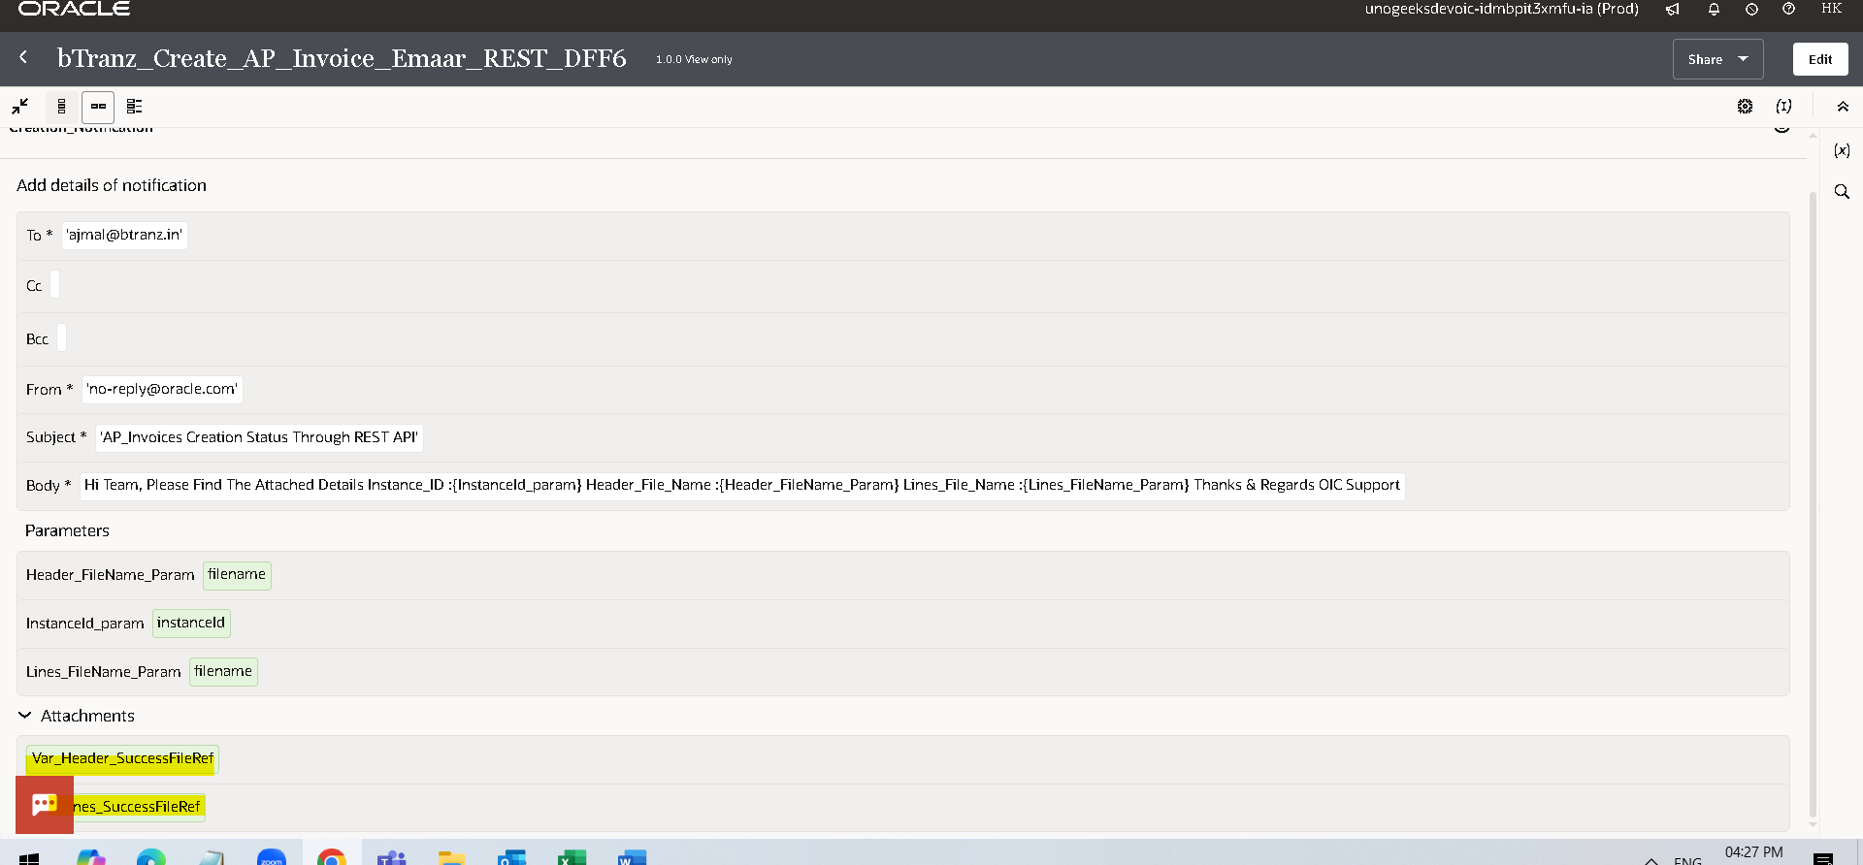
- Now we will move the file from in directory to archive directory using move operation of Fftp_Connection.
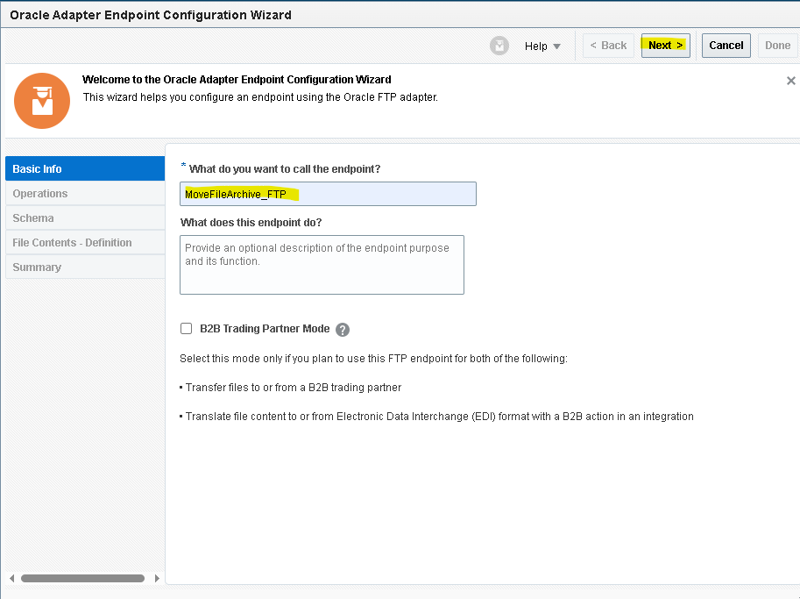
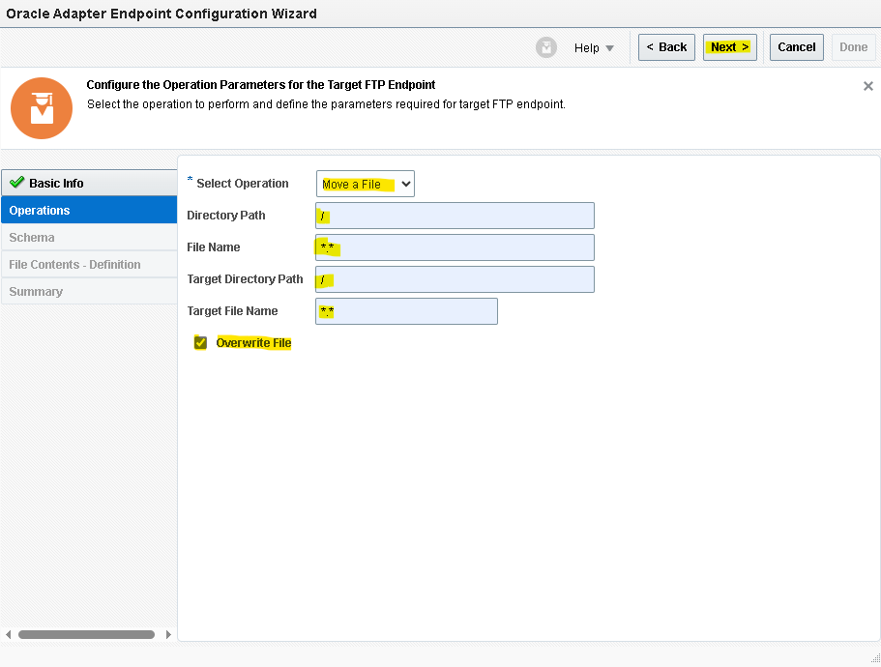
- Check the overwrite option as it removes the existing file and overwrite with new file in archive directory
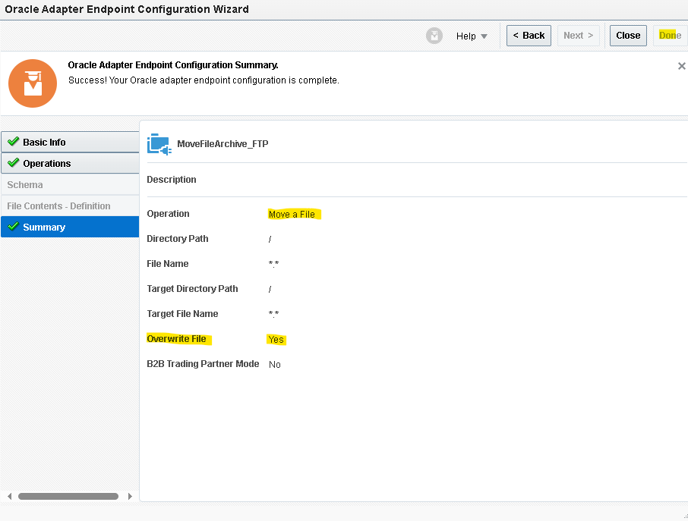
- We are having variables for in and archive directories we will map that variables to Directory and Target Directory respectively, Map the filename from CurrentHeaderSourcefile for both the filename and target filename
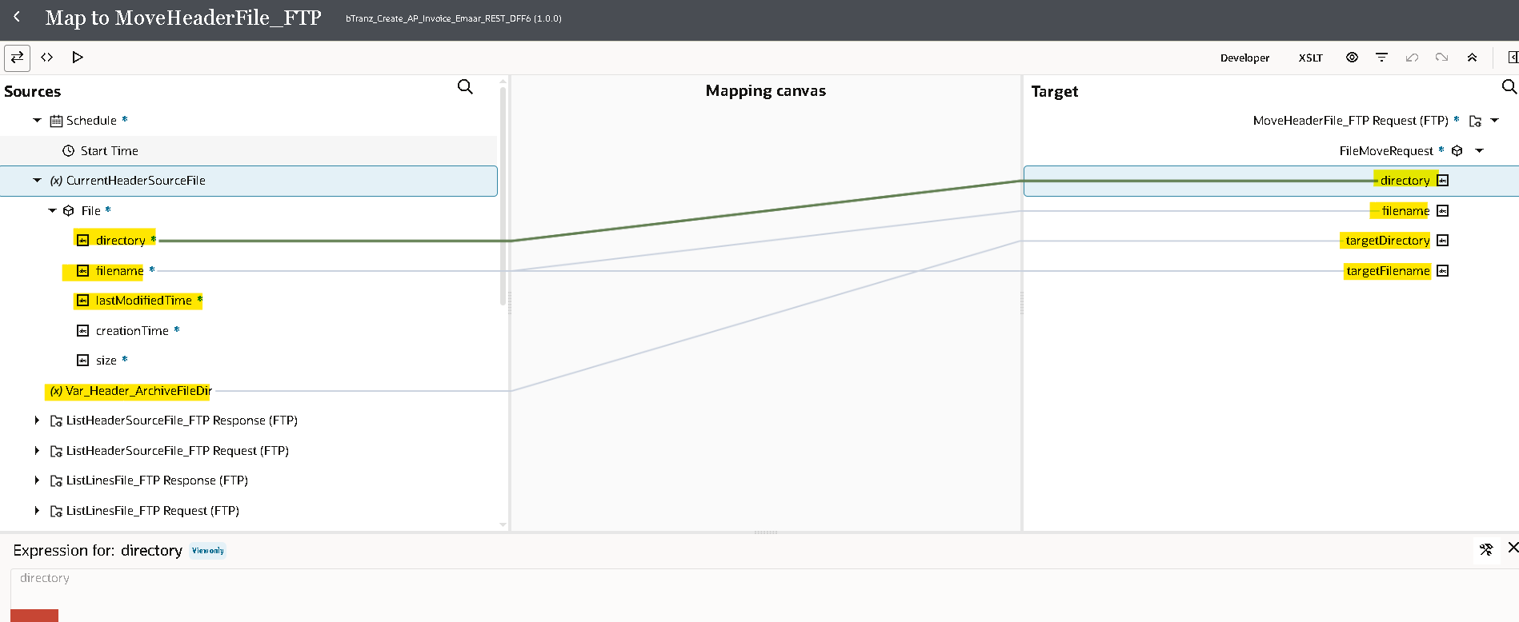
- Validate and repeat the same for CurrentLineSourceFile to move lines file to archive as given mapper.
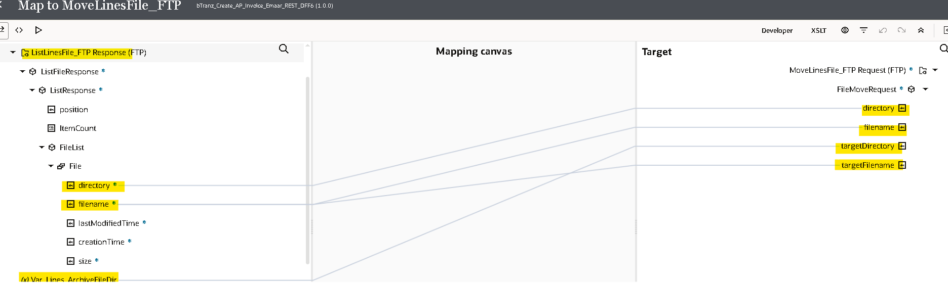

- For every integration we need to assign at least one tracking variable maximum we can assign up to three as it will be used when we are tracking the integration. here you can observe the error.
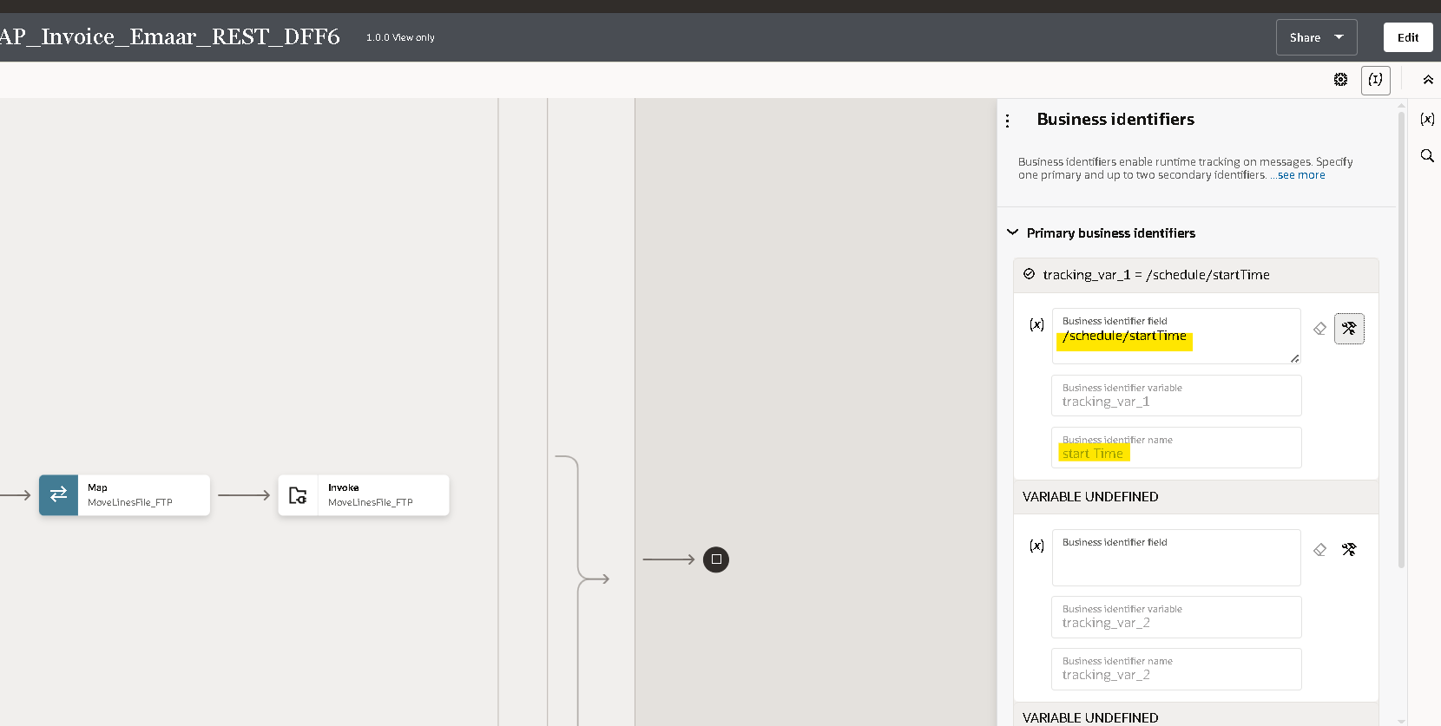
- Drag any variable from source to Tracking Field to mention it as Primary variable.

- Once you declare the tracking variable save and close the integration.
Running The Integration:

- Before running an integration, we need to activate it initially it will be in draft state after successful creation it will be in configured state after activating it will be in active state.
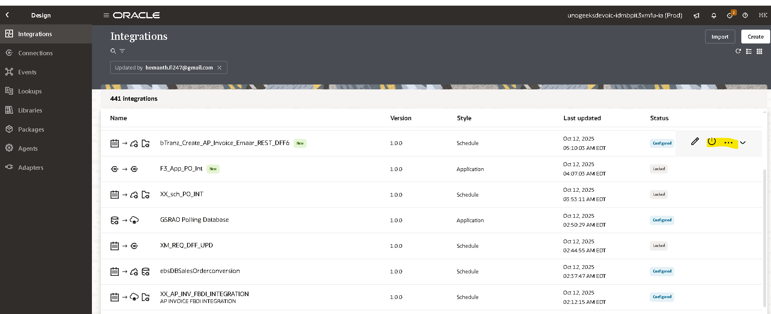
- You can activate and schedule as per your requirement it will run or you can just activate directly.
- By checking include debug option it helps you to check the payload of each operation in tracking page.

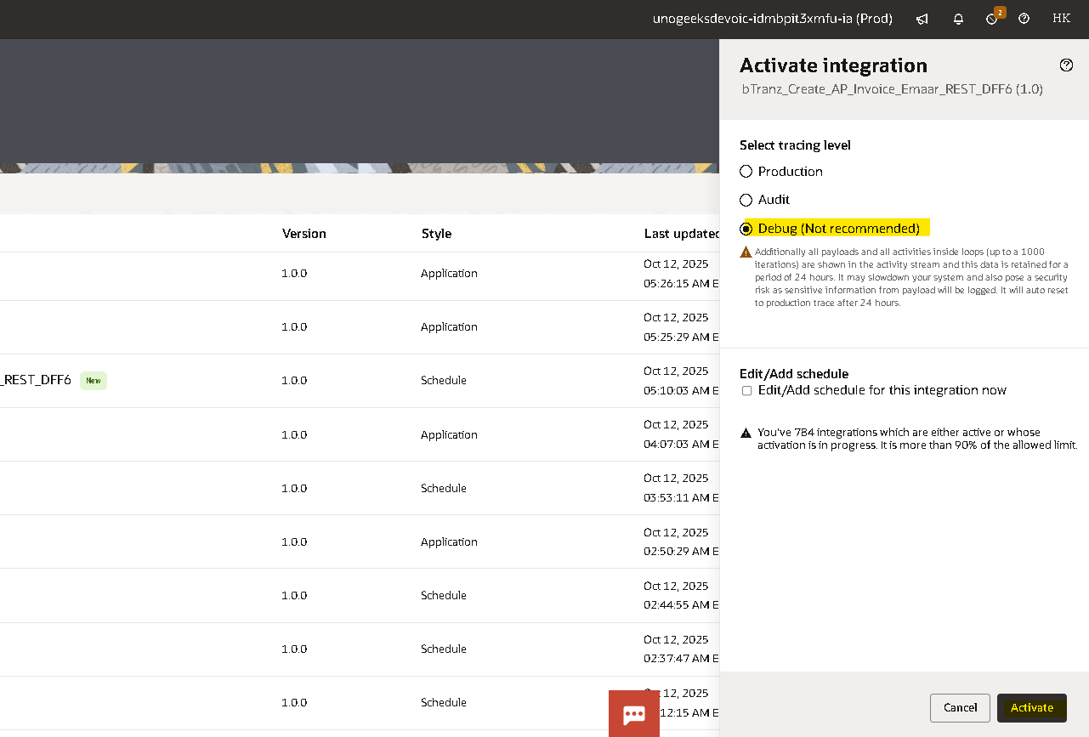
- By clicking on the three Dots and click on run
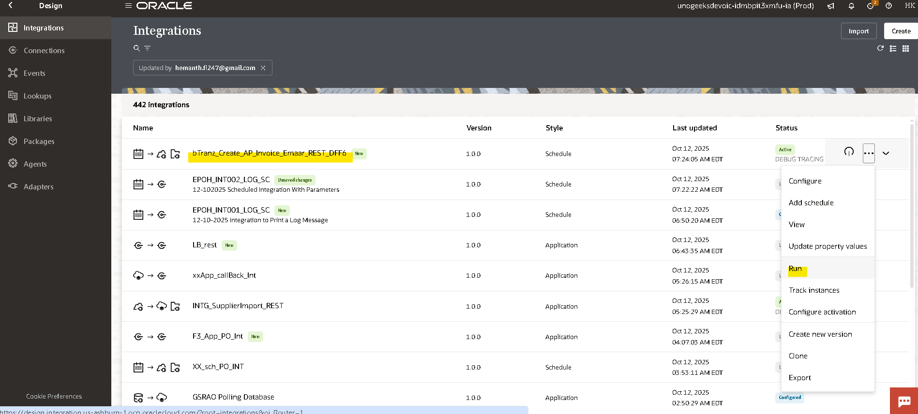
- Click on run again to submit instance to run.
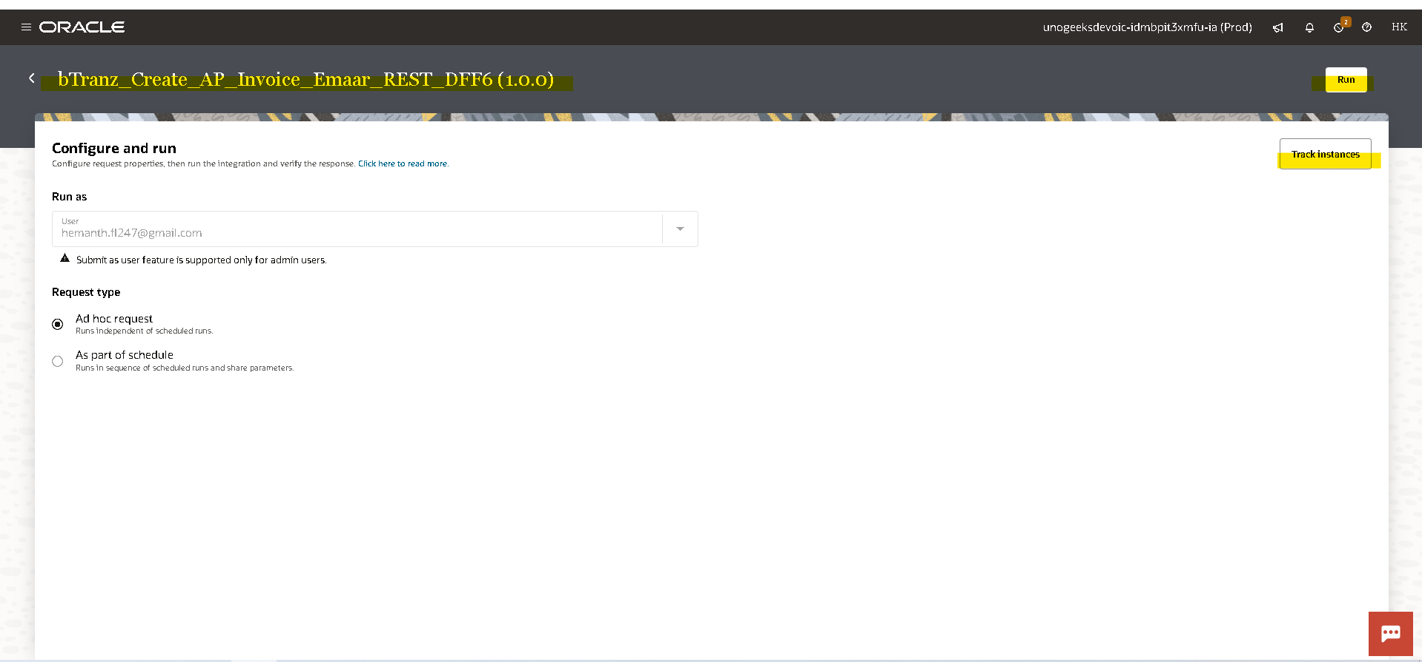
- You will get an InstanceId when you run the integration by clicking on that instance id you will be redirect to tracking page where you can check the status of that integration.
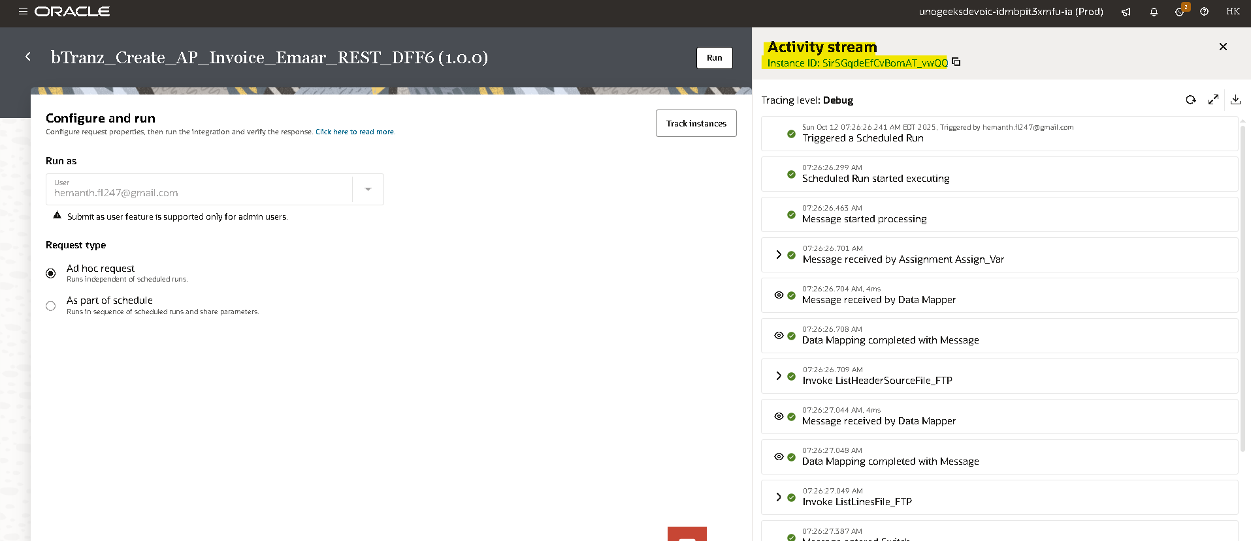

Tracking The Integration:

- To track the integration manually ObservabilityInstances

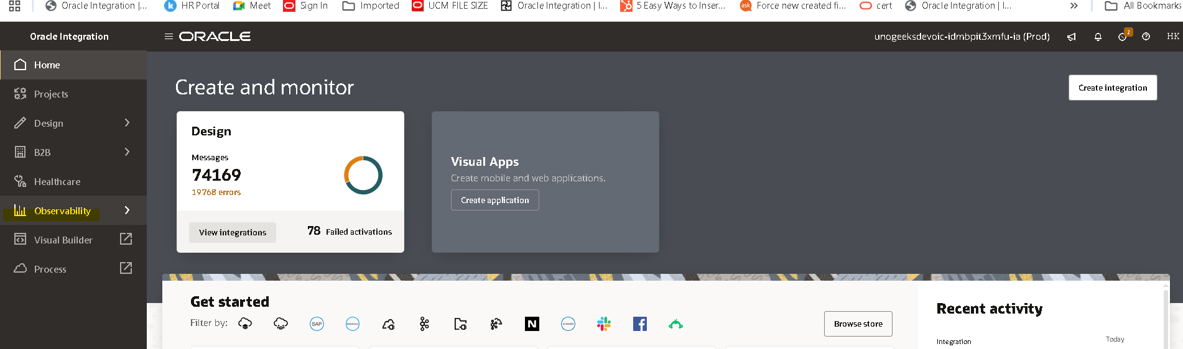
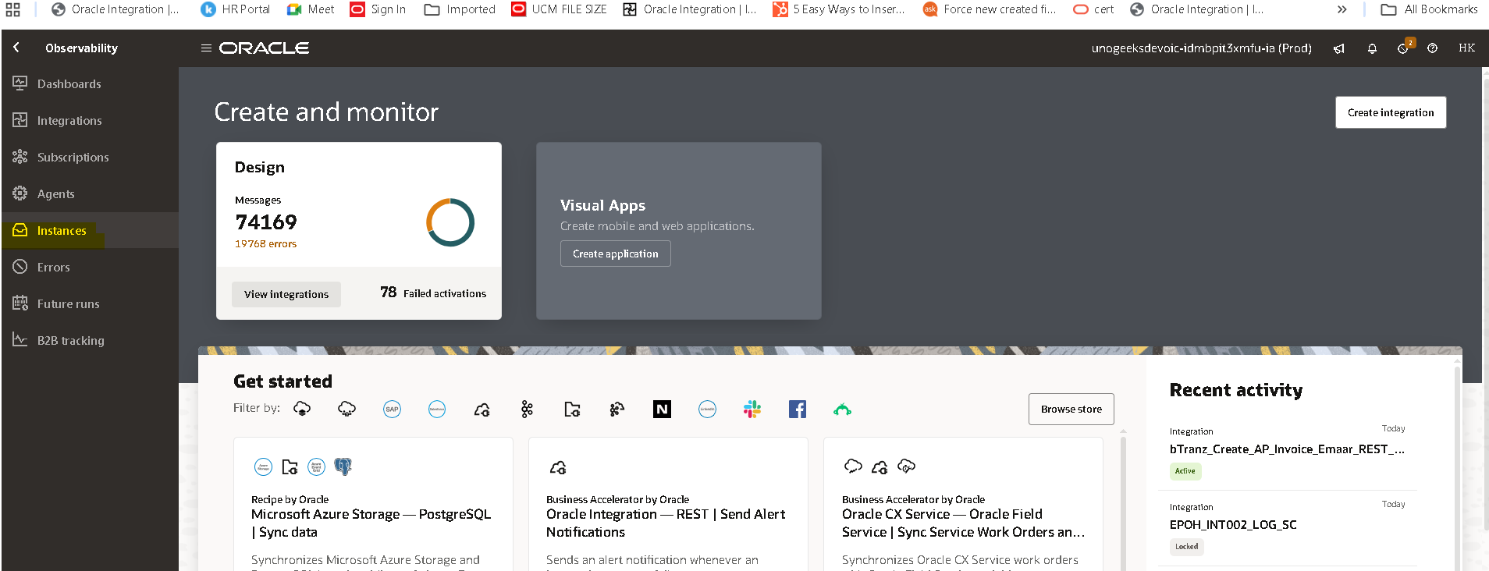

- Here you can observe the InstanceId and status of the integration (if you clicked on InstanceId while
running the integration you will be redirected here)
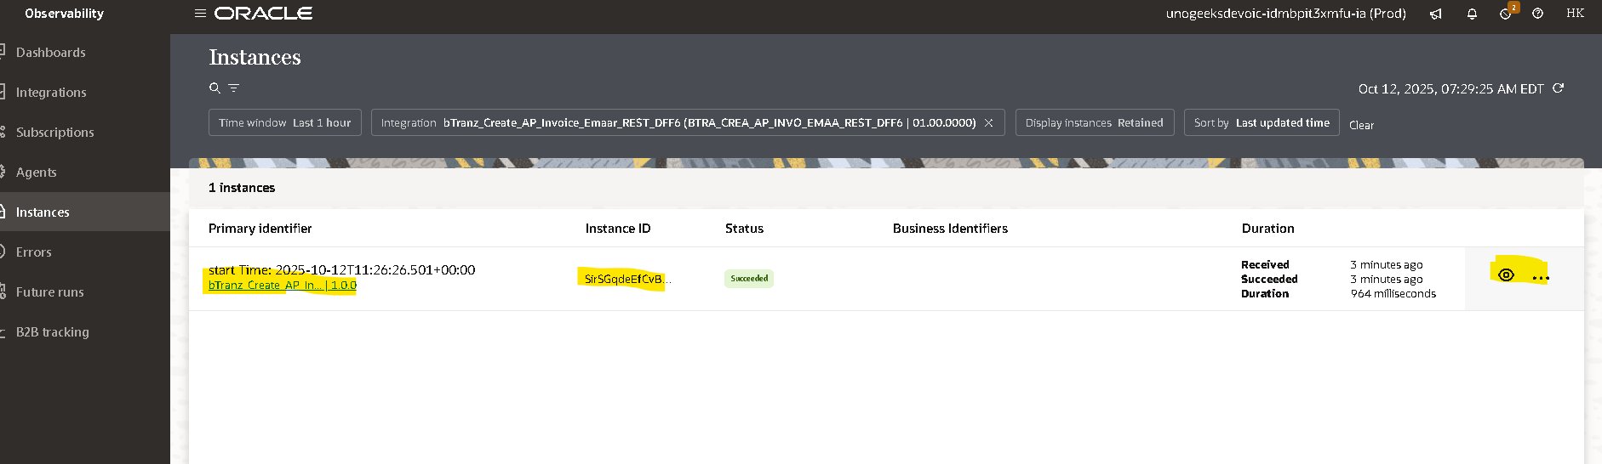
- By clicking on instance id in activity stream you can check the flow of the integration.
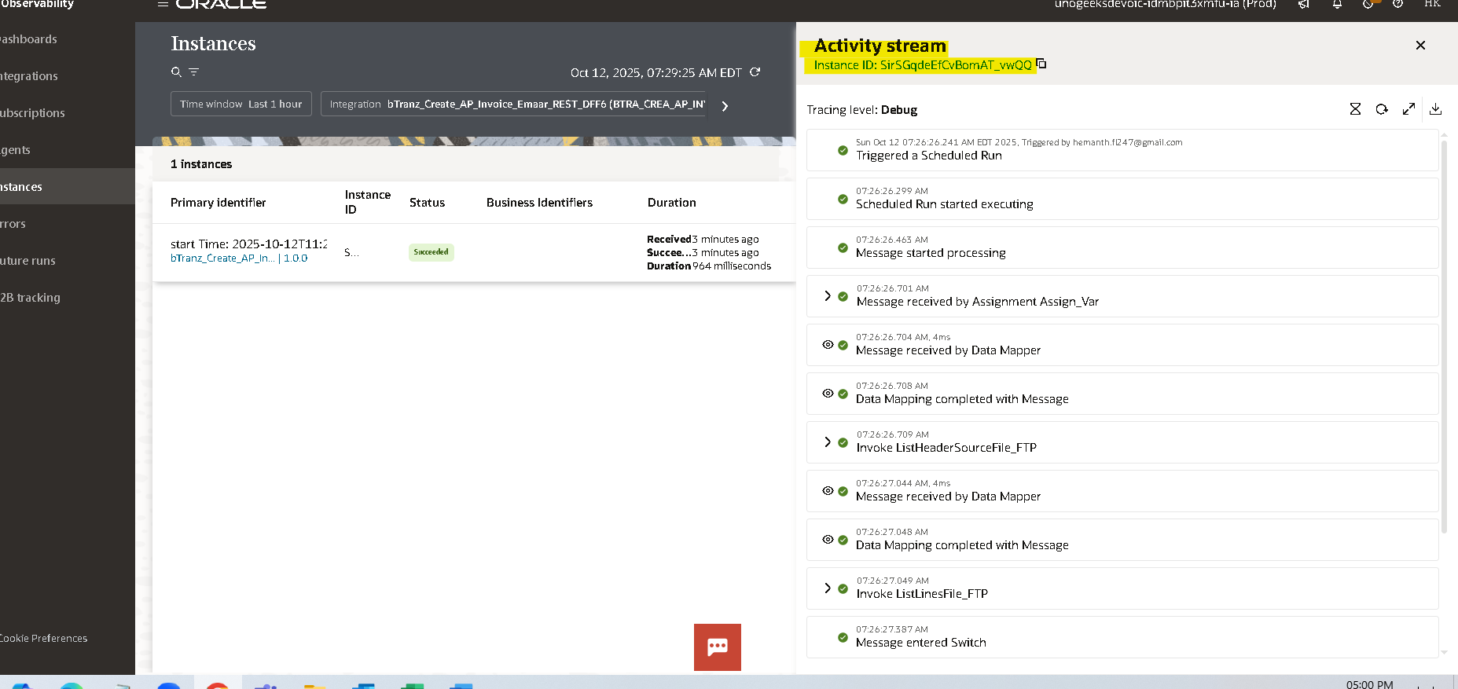

Open and Closed Issues for this Deliverable

Open Issues

ID | Issue | Resolution | Responsibility | Target Date | Impact Date

Closed Issues

ID | Issue | Resolution | Responsibility | Target Date | Impact Date

